WORKING DRAFT

03 March 2017

C:\Documents and Settings\julia.powell\My Documents\IHO TSMAD\S100-0 main\IHO S-100 Main Oct 1 2007.doc © ISO/IEC 2007 – All rights reservedISO-IEC_ 63Complementary elementIntroductory element — Main elementÉlément introductif — Élément central — Élément complémentaireIntroductory element — Main element — Complementary elementE2007-10-2 ISO/IECISO/IEC     2007 ISO/IEC ISO/IEC _(E).        2Heading 2Heading 1    02 STD Version 2.1c20   4

INTERNATIONAL HYDROGRAPHIC ORGANIZATION



Bathymetric Surface Product Specification

Edition 2.0.0 – WORKING DRAFT

IHO Publication S-102

Published by the

International Hydrographic Bureau

MONACO

|  |  |  |  |
| --- | --- | --- | --- |
| Version Number | Date | Author | Purpose |
| 1.0.0 | April 2012 | TSMAD | Approved edition of S-102 |
| 2.0.0 | March 2017 | S102PT | Updated clause 4.0 and 12.0.  Populated clause 9.0 and Annex B. |
|  |  |  |  |
|  |  |  |  |
|  |  |  |  |
|  |  |  |  |
|  |  |  |  |
|  |  |  |  |
|  |  |  |  |
|  |  |  |  |
|  |  |  |  |

Contents

1 Overview 5

1.1 Introduction 5

1.2 References 5

1.3 Terms, definitions and abbreviations 6

1.3.1 Use of Language 6

1.3.2 Terms and Definitions 6

1.3.3 Abbreviations 10

1.4 General S-102 Data Product Description 11

1.5 Data product specification metadata 12

1.5.1 IHO Product Specification Maintenance 13

2 Specification Scopes 14

3 Dataset Identification 14

4 Data Content and structure 17

4.1 Introduction 17

4.2 Application Schema <S-100 Part 3> 18

4.2.1 Application Schema Implementation Classes 21

4.2.2 Tiling Scheme (Partitioning) 30

4.3 Feature Catalogue 33

4.3.1 Introduction 33

4.3.2 Feature Types 33

4.3.3 Feature Relationship 34

4.3.4 Information Types 34

4.3.5 Attributes 34

4.4 Dataset Types 35

4.4.1 Introduction 35

4.4.2 Regular Grid 35

4.5 Dataset Types 36

4.6 Data Coverage rules 37

4.7 Dataset Loading and Unloading 37

4.7.1 Dataset Loading and Unloading Algorithm 37

4.8 Geometry <S-100 Part 7> 37

5 Coordinate Reference Systems (CRS) 37

5.1 Introduction 37

5.2 Spatial Reference System 38

5.3 Horizontal Coordinate Reference System 38

5.4 Vertical Coordinate Reference System 39

5.5 Temporal Reference System 39

6 Data Quality 39

7 Data Capture and Classification 39

8 Maintenance 40

8.1 Maintenance and Update Frequency: 40

8.2 Data Source: 40

8.3 Production Process: 40

9 Portrayal 40

9.1 Introduction 40

9.2 Display of Soundings Extracted from an S-102 Dataset 40

9.2.1 Sounding Selection and Display Parameters 41

9.2.2 Numerical display of Associated Uncertainty 41

9.4 Generation and Display of Safety Contour and Associated Depth Zones 43

10 Data Product format (encoding) 47

10.1 Introduction 47

11 Data Product Delivery 47

11.1 Introduction 47

11.2 Dataset 48

11.2.1 Datasets 48

11.2.2 Dataset file naming 48

11.3 Support Files 48

11.3.1 Support File Naming 49

11.4 Exchange Catalogue 49

12 Metadata 49

12.1 Introduction 49

12.2 Discovery Metadata 51

12.3 Structure Metadata 54

12.3.1 Quality Metadata 57

12.3.2 Acquisition Metadata 60

12.4 Exchange Set Metadata 60

12.5 Language 64

12.6 S102_ExchangeCatalogue 65

12.6.1 S102_CatalogueIdentifier 67

12.6.2 S102_CataloguePointofContact 67

12.7 S102_DatasetDiscoveryMetaData 68

12.7.1 S102_DataCoverage 73

12.7.2 S102_VerticalAndSoundingDatum 74

12.7.3 S102_DataFormat 76

12.7.4 S102_ProductSpecification 77

12.8 S102_SupportFileDiscoveryMetadata 78

12.8.1 S102_SupportFileFormat 80

12.8.2 S102_SupportFilePurpose 81

12.9 S102_CatalogueMetadata 81

12.9.1 S102_CatalogueScope 82

Annex A - Data Classification and Encoding Guide 83

A.1 Application Program Interface 88

A.1.1 Application Program General 88

A.1.2 Structure of the Source Tree 88

A.1.3 Basic Data Access 89

Annex B. HDF-5 ENCODING 92

B.1 Introduction 92

B.2 Metadata 93

B.3 Datasets 93

B.4 HDF5 Example Data 95

Annex C. Normative Implementation Guidance 97

Annex D. Feature Catalogue 97

Annex E. Portrayal Catalogue 97

Annex F. Surface Generalization 97

Annex G. Multi-Resolution Grid Display 97

# Overview

Concurrent with the advent of electronic navigation, the need for high resolution bathymetric data in the form of a bathymetric model has become a requirement to better enable the systematic fusion of temporal data such as tidal heights and also to enable the same data to be used for other applications where a shoal-biased model may not be optimal. Furthermore, having such a model allows an ECDIS or ECS to make other intelligent adjustments such as contour intervals.

The Bathymetric Surface data product described here incorporates the *Navigation Surface* concept. This means that, in addition to an estimation of depth and an estimate of the uncertainty associated with the depth, there is an ability to over-ride any automatically constructed depth estimates with ‘Hydrographer Privilege‘. Essentially, this is a means to specify directly the depth judged by a human observer as being the most significant in the area - irrespective of any statistical evidence to the contrary. The original grid values that are replaced by the hydrographer are preserved in the tracking list so that they can be restored if required.

## Introduction

This document describes an S-100 compliant product specification for a Bathymetric Surface Product.

Much of this document has been adapted from the Format Specification Document – Description of the Bathymetric Attributed Grid Object (BAG) Version 1.0.0. Compliance with the S-102 product specification implies logical compliance with the BAG as specified by the Open Navigation Surface Project.

Bathymetric Surface data may be used alone or it may be combined with ENC or other S-100 compatible data. As such this Bathymetric Surface product specification describes one of a number of additional layers that could be integrated with other S-100 products for use with ENC**.**

The Bathymetric Surface Data Product specification defines a content model and an exchange file format for the exchange of bathymetric coverage data. The coverage type is a quadrilateral grid coverage together with attributes. The bathymetric coverage consists of mandatory, collocated coverages of elevation and uncertainty. Other optional coverage may be contained as well.

The encoding specified in this Product specification is based on HDF5, but as content and encoding are separated, it does not preclude transformation to other encodings such as GeoTIFF and XML.

## References

S-100 IHO Universal Hydrographic Data Model

IHO S-100 IHO Universal Hydrographic Data Model, January 2010

IHO S-44 Standards for Hydrographic Surveys 5th Edition, February 2008

IHO S-4 Regulations of the IHO for International (INT) Charts and Chart Specifications of the IHO, Edition 4.6.0 – April 2016.

ISO 8601:2004 Data elements and interchange formats _ Information interchange _ Representation of dates and times

ISO/TS 19103:2005 Geographic information - Conceptual schema language

ISO 19111:2003 Geographic information - Spatial referencing by coordinates

ISO 19115:2003 Geographic information – Metadata

ISO 19115-2:2009 Geographic information - Metadata: Extensions for imagery and gridded data

ISO 19123:2005 Geographic information - Schema for coverage geometry and functions

ISO 19129:2009 Geographic information - Imagery gridded and coverage data framework

ISO 19131:2007 Geographic information - Data product specifications

ISO/IEC 19501:2005, Information technology — Open Distributed Processing - Unified Modelling

Language Version 1.4.2

Note: a summary of UML is given in S.100 Part 1

Format Specification Document - Description of Bathymetric Attributed Grid Object (BAG) - Version 1.0.0

## Terms, definitions and abbreviations

### Use of Language

Within this document:

* “Must” indicates a mandatory requirement.
* “Should” indicates an optional requirement, that is the recommended process to be followed, but is not mandatory.
* “May” means “allowed to” or “could possibly”, and is not mandatory.

### Terms and Definitions

#### Coordinate

one of a sequence of numbers designating the position of a point in N-dimensional space

[ISO 19111]

#### coordinate reference system

coordinate system which is related to the real world by a datum

[ISO 19123]

#### coverage

feature that acts as a function to return values from its range for any direct position within its spatial, temporal, or spatiotemporal domain

[ISO1912]

EXAMPLE: Examples include a digital image, polygon overlay, or digital elevation matrix.

NOTE: In other words, a coverage is a feature that has multiple values for each attribute type, where each direct position within the geometric representation of the feature has a single value for each attribute type.

#### coverage geometry

configuration of the domain of a coverage described in terms of coordinates

[ISO 19123]

#### direct position

position described by a single set of coordinates within a coordinate reference system

[ISO 19107]

#### domain

well-defined set

[ISO 19103]

NOTE: Domains are used to define the domain set and range set of operators and functions.

#### elevation

the altitude of the ground level of an object, measured from a specified vertical datum. [IHO:S100 GFM]

#### feature

abstraction of real world phenomena

[ISO 19101]

NOTE: A feature may occur as a type or an instance. Feature type or feature instance should be used when only one is meant.

#### feature attribute

characteristic of a feature

[ISO 19109]

NOTE: A feature attribute type has a name, a data type and a domain associated to it. A feature attribute instance has an attribute value taken from the value domain of the feature attribute type.

#### function

rule that associates each element from a **domain** (source, or domain of the function) to a unique element in another domain (target, co-domain, or **range**)

[ISO 19107]

NOTE: The range is defined by another domain.

#### geometric object

spatial object representing a set of **direct positions**

[ISO 19107]

NOTE: A geometric object consists of a **geometric primitive**, a collection of geometric primitives, or a geometric complex treated as a single entity. A geometric object may be the spatial characteristics of an object such as a **feature** or a significant part of a feature

#### grid

network composed of two or more sets of curves in which the members of each set intersect the members of the other sets in a systematic way

[ISO 19123]

NOTE: The curves partition a space into grid cells.

#### grid point

point located at the intersection of two or more curves in a **grid**

[ISO 19123]

#### height

distance of a point from a chosen reference surface measured upward along a line perpendicular to that surface

[ISO 19111:2006]

NOTE: Height is distinguished from elevation in that it is a directional measurement.

#### LIDAR

an optical remote sensing technique that uses a laser pulse to determine distance

NOTE: LIDAR may be used to determine depth in shallow water areas.

#### navigation surface

A BAG data object representing the bathymetry and associated uncertainty with the methods by which those objects can be manipulated, combined and used for a number of tasks, certified for safety of navigation

[ONS FSD]

#### range

<coverage>

set of values associated by a **function** with the elements of the **spatiotemporal domain** of a

**coverage**

[ISO 19123]

#### record

finite, named collection of related items (objects or values) [ISO 19107]

NOTE: Logically, a record is a set of pairs <name, item >.

#### rectified grid

**grid** for which there is a linear relationship between the **grid coordinates** and the coordinates of an external **coordinate reference system**

[ISO 19123]

NOTE: If the coordinate reference system is related to the earth by a datum, the grid is a georectified grid.

#### referenceable grid

**grid** associated with a transformation that can be used to convert grid coordinate values to values of

**coordinates** referenced to an **external coordinate reference system**

[ISO 19123]

#### SONAR

a technique that uses sound propagation through water to determine distance, primarily **depth**

measurement

#### spatiotemporal domain

<coverage>

**domain** composed of **geometric objects** described in terms of spatial and/or temporal **coordinates**

[ISO 19123]

NOTE: The spatiotemporal domain of a **continuous coverage** consists of a set of **direct positions** defined in relation to a collection of geometric objects.

#### surface

connected 2-dimensional **geometric primitive**, representing the continuous image of a region of a plane

[ISO 19107]

NOTE: The boundary of a surface is the set of oriented, closed curves that delineate the limits of the surface.

#### tiling scheme

a discrete grid coverage that is used to partition data into discrete edge matched sets called tiles

#### uncertainty

The interval (about a given value) that will contain the true value of the measurement at a specific confidence level

[IHO S44]

NOTE: Errors exist and are the differences between the measured value and the true value. Since the true value is never known it follows that the error itself cannot be known. Uncertainty is a statistical assessment of the likely magnitude of this error.

#### vector

quantity having direction as well as magnitude

[ISO 19123]

NOTE: A directed line segment represents a vector if the length and direction of the line segment are equal to the magnitude and direction of the vector. The term vector data refers to data that represents the spatial configuration of features as a set of directed line segments.

### Abbreviations

This product specification adopts the following convention for presentation purposes:

API Application Programming Interface

BAG Bathymetric Attributed Grid

DS Digital Signature

DSS Digital Signature Scheme

ECDIS Electronic Chart Display Information System

ECS Electronic Chart System

ENC Electronic Navigational Chart

GML Geography Markup Language

IHO International Hydrographic Organization

ISO International Standards Organization

LIDAR Light Detection And Ranging

NS Navigation Surface

ONS Open Navigation Surface

PK Public Key

SA Signature Authority

SK Secret Key

SONAR Sound Navigation And Ranging

UML Universal Modelling Language

## General S-102 Data Product Description

Title: S-102 – Bathymetric Surface Product Specification

Abstract: This document is a product specification for bathymetric surface data which may be used alone or as an auxiliary layer of data with an ENC. It specifies a navigation surface coverage including both depth and uncertainty together with an optional tracking list of the depth changes that have been manually replaced in the surface by the hydrographer to override the statistical grid value points to ensure safety of navigation. This product specification includes a content model and separate encodings.

**Content:** The Product Specification defines all requirements to which S-102 bathymetric data products must conform. Specifically it defines the data product content in terms of features and attributes within the feature catalogue. The display of features is defined by the symbols and rule sets contained in the portrayal catalogue. The Data Classification and Encoding Guide (DCEG) provides guidance on how data product content must be captured. (Annex A) In addition, Annex C will provide implementation guidance for developers.

Spatial Extent:

Description: Areas specific to marine navigation.

East Bounding Longitude: 180°

West Bounding Longitude: -180°

North Bounding Latitude: 90°

South Bounding Latitude: -90°

**Purpose:** A Bathymetric Surface Data Product contains the grid data values required to define a coverage data set representing the depth, and the associated uncertainty of that depth, of the sea or other navigable waterway together with associated metadata. The coverage data include an additional point set of values called "track changes" that provides an audit of hydrographer overrides to the original bathymetric surface to ensure the product supports safe navigation. It also provides for the inclusion of optional layers including a separation layer that provides the definition of the offsets between chart datum and mean sea level as well as the ellipsoidal surface. The data product may be use independently or as a part of a set of auxiliary data layers to be used with ENC data or other S-100 data products. The metadata data and structure required to support the aggregation of a set of auxiliary data layers are described in S-100 Part 8 Clause 8.7.

A Bathymetric Surface Data Product may exist anywhere in the maritime domain. There are no limitations to its extent. A particular supplier, such as a national hydrographic office, may establish its own series of ENCs and auxiliary data that can be used together or with other S-100 data. These series may include Bathymetric Surface data. When used together with other data layers the requirement is that the reference system be the same or be directly convertible for all layers and that the tiling schemes align.

## Data product specification metadata

This information uniquely identifies this Product Specification and provides information about its creation and maintenance. For further information on dataset metadata see the metadata clause.

Title: The International Hydrographic Organization Bathymetric Surface Product Specification

S-100 Version:2.0.0

S-10n Version: 2.0.0

Date: TBD

Language: English

Classification: Unclassified

Contact: International Hydrographic Bureau

4 Quai Antoine 1er

B.P. 445

MC 98011 MONACO CEDEX  
Telephone: +377 93 10 81 00  
Fax: + 377 93 10 81 40

URL: www.iho.int

Identifier: S-102

Maintenance: Changes to the Product Specification S-102 are coordinated by the S-100 working group of the IHO and must be made available via the IHO web site. Maintenance of the Product Specification must conform to IHO Technical Resolution 2/2007 (revised 2010).

### IHO Product Specification Maintenance

#### Introduction

Changes to S-102 will be released by the IHO as a new edition, revision, or clarification.

#### New Edition

New Editionsof S-102 introduce significant changes. *New Editions* enable new concepts, such as the ability to support new functions or applications, or the introduction of new constructs or data types. *New Editions* are likely to have a significant impact on either existing users or future users of S-102.

#### Revisions

*Revisions* are defined as substantive semantic changes to S-102. Typically, revisions will change S-102 to correct factual errors; introduce necessary changes that have become evident as a result of practical experience or changing circumstances. A *revision* must not be classified as a clarification. *Revisions* could have an impact on either existing users or future users of S-102. All cumulative *clarifications* must be included with the release of approved corrections revisions.

Changes in a revision are minor and ensure backward compatibility with the previous versions within the same Edition. Newer revisions, for example, introduce new features and attributes. Within the same Edition, a dataset of one version could always be processed with a later version of the feature and portrayal catalogues.

In most cases a new feature or portrayal catalogue will result in a revision of S-102.

#### Clarification

Clarifications are non-substantive changes to S-102. Typically, clarifications: remove ambiguity; correct grammatical and spelling errors; amend or update cross references; insert improved graphics in spelling, punctuation and grammar. A clarification must not cause any substantive semantic change to S-102.

Changes in a clarification are minor and ensure backward compatibility with the previous versions within the same Edition. Within the same Edition, a dataset of one clarification version could always be processed with a later version of the feature and portrayal catalogues, and a portrayal catalogue can always rely on earlier versions of the feature catalogues.

#### Version Numbers

The associated version control numbering to identify changes (n) to S-102 must be as follows:

New Editions denoted as **n**.0.0

Revisions denoted as n.**n**.0

Clarifications denoted as n.n.**n**

# Specification Scopes

The Bathymetric Surface Data Product specification defines a content model and exchange file format for the exchange of bathymetric coverage data. The coverage type is a multi–layered quadrilateral grid coverage together with attributes.

A single S-102 coverage object represents one contiguous area of the skin of the Earth at a single resolution, but can represent data at any stage of the process from raw grid to final product. The term Navigation Surface (NS) is reserved for a final product BAG certified specifically for safety of navigation purposes.

An Application Programming Interface (API) exists which provides an abstraction from the underlying technologies as well as providing a set of methods for an application programmer to easily read and write data conforming to the BAG specification.

Each data supplier, such as a national hydrographic office, may establish its own series of bathymetric data products that may be used independently or in conjunction with other auxiliary data layers.

Scope ID: Global

Level: 006 - series

Level name: BAG

# Dataset Identification

Title: S-102 Bathymetry Surface

Alternate Title: BAG – Bathymetric Attributed Grid

**Abstract:** The Bathymetric Surface Data Product consists of a set of grid value matrix values organized to form a quadrilateral grid coverage with associated metadata representing a bathymetric depth model for an area of the sea, river, lake or other navigable water. The data set includes both depth estimate values and uncertainty estimates associated with the depth values. In addition a discrete point set called a "tracking list" allows a hydrographer to override any particular grid matrix value to deliberately bias the data for safety of navigation. That is, the data set can carry both measured depth information that may be used for scientific purposes as well as corrected depth information that may be used for navigation.

Topic Category: Main topics for the product, as defined by the ISO 19115 MD_TopicCategoryCode:

006 – elevation

012 – oceans

014 – inlandWaters

Geographic Description: Areas specific to marine navigation.

**Spatial Resolution:** The spatial resolution, or the spatial dimension on the earth covered by the size of a grid matrix cell (nominal ground sample distance), varies according to the model adopted by the producer (hydrographic office).

An S-102 dataset and **Data Coverage** must carry a value for maximum display scale. Each **Data Coverage** must also carry a value for minimum display scale. Values must be taken from the following table:

Table 3.1- S-102 Minimum Display and Maximum Display Scales / Corresponding Grid Size.

|  |  |
| --- | --- |
| **Scale** | **Corresponding Grid Size** |
| NULL (only allowed on minimum display scale where the maximum display scale = 10,000,000) |  |
| 1:10,000,000 |  |
| 1:3,500,000 |  |
| 1:1,500,000 |  |
| 1:700,000 |  |
| 1:350,000 |  |
| 1:180,000 |  |
| 1:90,000 |  |
| 1:45,000 |  |
| 1:22,000 |  |
| 1:12,000 |  |
| 1:8,000 |  |
| 1:4,000 |  |
| 1:3,000 |  |
| 1:2,000 |  |
| 1:1,000 |  |

**Purpose:** The primary purpose of the Bathymetric Surface Data Product is to support safe navigation as an auxiliary aid to navigation that may be used together with an ENC. The secondary use is as an independent source of depth information that may be used for other purposes.

Language: English (Mandatory), other (Optional)

Classification: Data can be classified as one of the following:

Unclassified

Restricted

Confidential

Secret

Top Secret

**Spatial Representation Type:** Type of spatial representation for the product, as defined by the ISO 19115

MD_SpatialRepresentationTypeCode:

002 - grid.

Point of Contact: Producing Agency

Use Limitation: For SOLAS navigation an S-102 dataset must have a corresponding S-101 ENC dataset.

# Data Content and structure

## Introduction

The Navigation Surface concept used in the Bathymetric Surface Data Product requires that in addition to estimation of depth, an estimate of the uncertainty associated with the depth must be computed and preserved. In order to make the system suitable to support safety of navigation applications, there is a means to over-ride any automatically constructed depth estimates with ‘Hydrographer Privilege‘, (essentially , a means to specify directly the depth determined by a human observer as being the most significant in the area - irrespective of any statistical evidence to the contrary). The original grid values that are replaced by the hydrographer are preserved in the tracking list so that they can be restored if required.

The Bathymetric Surface Data Product uses elevation for the vertical component of the BAG, as explained in clause 5.1.

Figure 1 shows a high level overview of the structure of S-102. It shows that the Bathymetric Surface Data Product consists of a set of data comprising the Bathymetric Attributed Grid plus a Digital Certification Block. The Digital Certification Block is mandatory when the data product is produced for navigational purposes so that the user can trace whether the data has been certified. The BAG consists of a version tag plus other metadata, together with coverages consisting of elevation values and an uncertainty as two collocated coverages as well as the tracking list. S-102 used the IHO S-63 Data Protection Scheme to ensure certification and authentication.

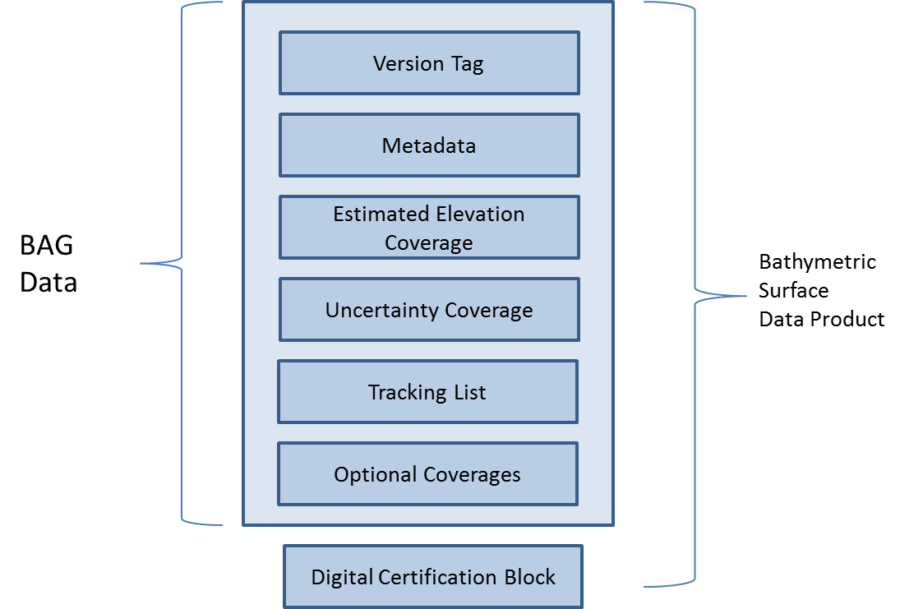

Figure 4.1 - Overview Structure of S-102

Thus, the Bathymetric Surface Data Product is a hybrid of coverage(s), as defined in

IHO S-100 Part 8, and Information Types as defined in IHO S-100 Part 4, together with a point set tracking list. This is described in clause 4.2.

## Application Schema

The Application Schema for S-102 is a template application schema. That is, it does not resolve all attributes and allows some choice. This means that an implementer, such as a national hydrographic office, can produce another application schema as a profile of this application schema that makes additional choices. For example, the choice of whether to use a tiling scheme and which tiling scheme to use is left open. An implementer, such as a national hydrographic office, can select the tiling scheme, extent, resolution and other parameters most appropriate for their situation. Since the general structure is defined by the template Application Schema, common software that supports the S-102 template schema is able to support national and other more specific profiles.

The Application Schema Data Set Structure is shown in Figures 2 and 3. They show a number of classes specialized for use in S-102 and two sets of implementation classes. An actual data set of S-102 bathymetry data only contains the implementation classes. All of the required attributes from the other classes in the application schema are satisfied by statements within the product specification. This approach to producing the application schema1 results in a very simple structure for implementation.

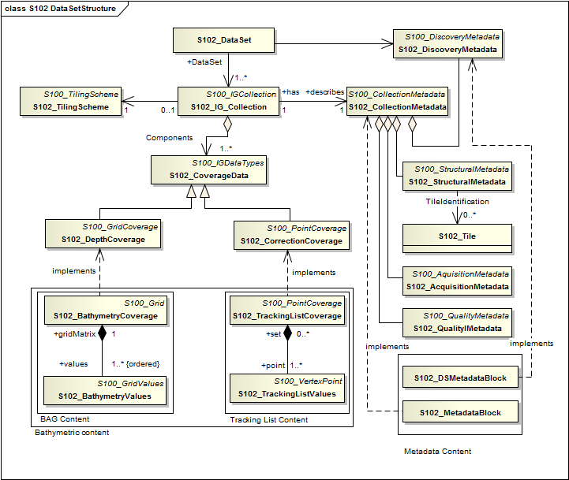

Figure 4.2 - Data Set Structure of S-102

The model in Figure 4.2 states that:

An S-102 data set (**S102_DataSet**), which is inherited from **S100_DataSet**, references an S-102 Image and Gridded Data Collection (**S102_IGCollection**). The relationship allows a 1 to many (**1..\***) multiplicity which means that there may be multiple instances of S-102 data collections. Each collection may or may not correspond to a tiling scheme, and each S102 DataSet would correspond to a single tile. The S-102 discovery metadata class (**S102_DiscoveryMetadata**) describes the metadata entities required for the identification of the entire data set. The required discovery metadata is implemented through the **S102_DSMetadataBlock** class.

An instance of an S-102 Image and Gridded Data Collection (**S102_IGCollection**) which is a subtype of **S100_ IGCollection**, is described by a set of S-102 Collection Metadata (**S102_CollectionMetadata**). This relationship is 1 to 1 meaning that there is one set of collection metadata for each instance of **S102_IGCollection**. There is a large choice of metadata that may be used in a S-100 compliant data product. Only a small amount of this metadata is mandated by ISO 19115 for discovery. The choice of metadata is discussed in clause 9.2.5. Much of the metadata can be resolved as part of the product specification. Only that metadata that varies IG_collection item to item needs be included in the S102_MetadataBlock implementation class.

An S-102 Image and Gridded Data Collection also optionally makes reference to a tiling scheme.

This is discussed further in clause 4.2.2.

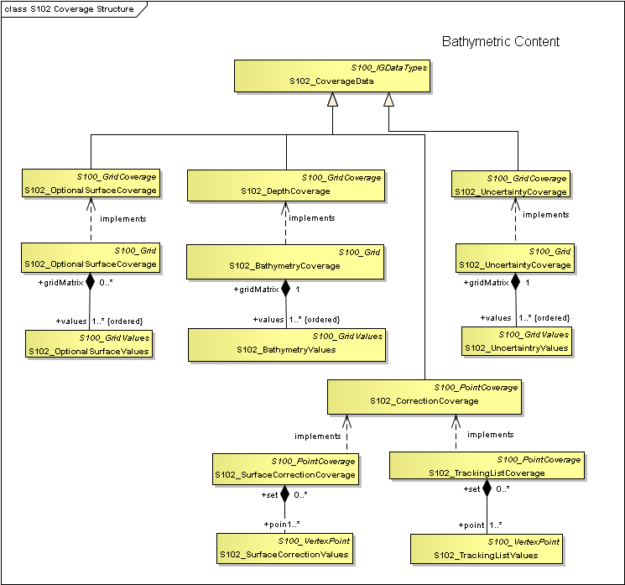

Figure 4.3 - Coverage Structure of S-102

The model in Figure 3 states that:

There are two coverage types in this application schema. The first is a set of discrete Quadrilateral Grid Coverages called **S102_DepthCoverage** and **S102_UncertaintyCoverage** and **S102_OptionalSurfaceCoverage** all of which it inherits from (**S100_GridCoverage**). Many of the parameters of the coverage are described in the product specification. These implementation classes are co-registered, co-geospatially located datasets.

The second coverage type is discrete point set coverage called **S102_CorrectionCoverage** and the **S102_TrackingListCoverage**. **The S102_TrackingListCoverage** consists of a set of discrete points that correspond to locations which had corrective overrides applied. (I.E. A hydrographer may explicitly specify depth values at specific points to deliberately ensure safety of navigation.) The **S102_CorrectionCoverage** is provided for pedigree. A coverage function to determine depth would operate on the resultant conflated continuous mathematical surface. The conflation function simply replaces specific values from the S102_BathymetryValues grid values matrix with the corresponding overriding values.

### Application Schema Implementation Classes

The implementation classes for the template application schema are shown in Figure 4. The attributes are shown for the coverage related classes together with the attribute classes.

In order to simplify the implementation a number of defaults are assumed for S-102. These defaults make the implementation very simple, and ensures an instance of an S-102 Bathymetric Surface Product Specification in HDF5 encoding parallels the Navigation Surface implementation from the Open Navigation Surface Working Group. In the following sub clauses the default values are emphasised so that they do not need to be encoded when generating an encoding of the implementation classes. However, if specified they must assume the stated values unless other options are stated.

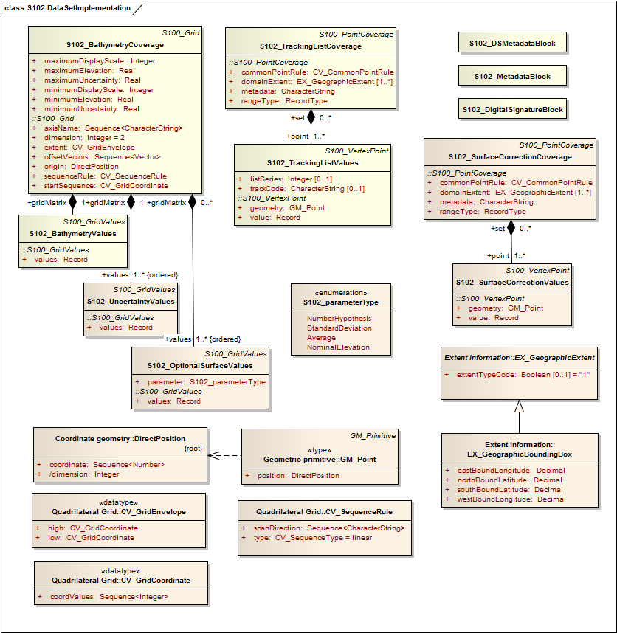

Figure 4.4 - Implementation of Classes of S-102

#### Implementation Classes Description

##### S102_BathymetryCoverage

###### S102_BathymetryCoverage semantics

The class **S102_BathymetryCoverage** has the attributes *minimumElevation, maximumElevation, minimumUncertainity*, and *maximumUncertainty* which bound the *depthEstimate* attribute and the *uncertainity* attribute from the **S102_BathymetryValues** record and **S102_UncertaintyValues** record and the inherited attributes *origin, offsetVectors, dimension, axisName, extent, sequenceRule*, and *startSequence* from **S100_Grid** and **CV_Grid**. The origin is a position in a specified coordinate reference system, and a set of offset vectors specify the direction and distance between the grid lines. It also contains the additional geometric characteristics of a rectified grid.

###### minimumElevation

The attribute *minimumElevation* has the value type *Real* and describes the lower bound of the depth estimate for all the *depthEstimate* values in **S102_BathymetryValues** record. This attribute is required. There is no default.

###### maximumElevation

The attribute *maximumElevation* has the value type *Real* and describes the upper bound of the depth estimate for all the *depthEstimate* values in **S102_BathymetryValues** record. This attribute is required. There is no default.

###### minimumUncertainty

The attribute *minimumUncertainty* has the value type *Real* and describes the lower bound of the uncertainty of the depth estimate for all the *depthEstimate* values in **S102_BathymetryValues** record. This attribute is required. There is no default.

###### maximumUncertainty

The attribute *maximumUncertainty* has the value type *Real* and describes the upper bound of the uncertainty of the depth estimate for all the *depthEstimate* values in **S102_BathymetryValues** record. This attribute is required. There is no default.

###### origin

The attribute *origin* has the value class *DirectPosition* which is a position that shall locate the origin of the rectified grid in the coordinate reference system. This attribute is required. There is no default.

###### offsetVectors

The attribute *offsetVectors* has the value class *Sequence<Vector>* that shall be a sequence of offset vector elements that determine the grid spacing in each direction. The data type Vector is specified in ISO/TS 19103. This attribute is required. There is no default.

###### dimension

The attribute *dimension* has the value class *Integer* that shall identify the dimensionality of the grid. The value of the grid dimension in this product specification is 2. This value is fixed in this product specification and does not need to be encoded.

###### axisName

The attribute *axisName* has the value class *Sequence<CharacterString>* that shall be used to assign names to the grid axis. The grid axis names shall be "Latitude" and "Longitude" for unprojected data sets or ―Northing‖ and ―Easting‖ in a projected space.

###### extent

The attribute *extent* has the value class **CV_GridEnvelope** that shall contain the extent of the spatial domain of the coverage. It uses the value class **CV_GridEnvelope** which provides the grid coordinate values for the diametrically opposed corners of the grid. The default is that this value is derived from the bounding box for the data set or tile in a multi tile data set.

###### sequenceRule

The attribute *sequenceRule* has the value class **CV_SequenceRule** that shall describe how the grid points are ordered for association to the elements of the sequence values. The default value is "Linear". No other options are allowed.

###### startSequence

The attribute *startSequence* has the value class **CV_GridCoordinate** that shall identify the grid point to be associated with the first record in the values sequence. The default value is the lower left corner of the grid. No other options are allowed.

##### S102_BathymetryValues

###### S102_BathymetryValues semantics

The class **S102_BathymetryValues** is related to **S102_BathymetryCoverage** by a composition relationship in which an ordered sequence of depthEstimate values provide data values for each grid cell. The class **S102_BathymetryValues** inherits from S100_Grid.

###### values

The attribute *values* has the values class *Record* which is a sequence of value items that shall assign values to the grid points. There is a single value in each record in the **S102_BathymetryValues** class which provides the ***depthEstimate*** for the grid cell***.*** The definition for the depth type is defined by the *depthCorrectionType* attribute in the **S102_BAGDataIdentification** class.

##### S102_UncertaintyValues

###### S102_UncertaintyValues semantics

The class **S102_UncertaintyValues** is related to **S102_BathymetryCoverage** by a composition relationship in which an ordered sequence of uncertainty values provide data values for each grid cell.

###### values

The attribute *values* has the values class *Record* which is a sequence of value items that shall assign values to the grid point. There is a single value in each record in the **S102_UncertaintyValues** class which provides the uncertainty for the grid cell. The definition of the type of data in the values record is defined by the *verticalUncertaintyType* attribute in the **S102_BAGDataIdentification** class.

##### S102_OptionalSurfaceValues

###### S102_OptionalSurfaceValues semantics

The class **S102_OptionalSurfaceValues** is related to **S102_BathymetryCoverage** by a composition relationship in which an ordered sequence of optional values provide data values for each grid cell forming a surface for an optional parameter. The parameter type is specified in the attribute *parameter*. Note, there may be 0 or more **S102_OptionalSurfaceValues** per **S102_BathymetryCoverage.**

###### parameter

The attribute *parameter* identifies the type of data in the *values* record*.*

###### values

The attribute *values* has the values class *Record* which is a sequence of value items that shall assign values to the grid point. There is a single value in each record in the **S102_OptionalSurfacesValues** class which provides the parameter value for the grid cell. The definition of the type of data in the values record is defined by the *parameter* attribute.

##### DirectPosition

###### DirectPosition semantics

The class DirectPosition hold the coordinates for a position within some coordinate reference system.

###### coordinate

The attribute *coordinate* is a sequence of Numbers that hold the coordinate of this position in the specified reference system.

###### dimension

The attribute *dimension* is a derived attribute that describes the length of coordinate.

##### CV_GridEnvelope

###### CV_GridEnvelope semantics

The class **CV_GridEnvelope** provides the grid coordinate values for the diametrically opposed corners of an envelope that bounds a grid. It has two attributes.

###### low

The attribute *low* shall be the minimal coordinate values for all grid points within the envelope. For this specification this represents the Southwestern coordinate.

###### high

The attribute *high* shall be the maximal coordinate values for all grid points within the envelope. For this specification this represents the Northeastern coordinate.

##### CV_GridCoordinate

###### CV_GridCoordinate semantics

The class **CV_GridCoordinate** is a data type for holding the grid coordinates of a **CV_GridPoint.**

###### coordValues

The attribute *coordValues* has the value class *Sequence* *Integer* that shall hold one integer value for each dimension of the grid. The ordering of these coordinate values shall be the same as that of the elements of *axisNames*. The value of a single coordinate shall be the number of offsets from the origin of the grid in the direction of a specific axis.

##### CV_SequenceRule

###### CV_SequenceRule semantics

The class **CV_SequenceRule** contains information for mapping grid coordinates to a position within the sequence of records of feature attribute values. It has two attributes.

###### type

The attribute *type* shall identify the type of sequencing method that shall be used. A code list of scan types is provided in S-100 Part 8. Only the value ―linear‖ shall be used in S-102, which describes scanning row by row by column.

##### scanDirection

The attribute *scanDirection* has the value class *Sequence<CharacterString>* a list of axis names that indicates the order in which grid points shall be mapped to position within the sequence of records of feature attribute values. The scan direction for all layers in S-102 is "Longitude" and "Latitude" or west to east, then south to north.

##### S102_TrackingListCoverage

###### S102_ TrackingListCoverage semantics

The class **S102_TrackingListCoverage** has the attributes *domainExtent, rangeType, CommonPointRule* and *metadata* inherited from **S100_PointCoverage**. The **S102_TrackingList Coverage** is a discrete point coverage which is used to track overriden nodes in the **S102_BathymetryCoverage** by allowing a hydrographer to apply a bias for safety of navigation. The attribute *metadata* provides one method of linking the metadata to the coverage inherited from S-100, however it is not required in S-102 because there is no need for specific metadata at the feature (class) level. The attribute *commonPointRule* is also not required because the value has been established for the whole of the S-102 data product to be "average". The attribute *rangeType* takes on the value class *RecordType*. This is modelled by the composition of multiple instances of **S102_TrackingListValues**. Therefore only the attribute *domainExtent* is required, and it has a default value.

###### domainExtent

The attribute *domainExtent* has the value class *EX_GeographicExtent* which describes the spatial boundaries of the tracking list elements within the bounds established by CV_GridEnvelope for the S102_BathymetryGrid. The default is the bounds established by the attribute CV_GridEnvelope.

##### S102_TrackingListValues

###### S102_TrackingListValues semantics

The class **S102_TrackingListValues** has the attributes *trackCode* and *listSeries* and the attributes *geometry,* and *value* inherited from **S100_VertexPoint** and **CV_GeometryValuePair**. The tracking list is a discrete coverage used to furnish the set of values that were overriden in the **S102_BathymetryValues** class. In order to assure alignment of tracking list values with the grid cells in the bathymetry coverage grid, the reference system for the tracking list is the bathymetry coverage quadrilateral grid.

The *trackCode* value and the *listSeries* value provide context for the override a value from the bathymetry coverage. The *trackCode* value is a text string that describes the reason for the override.

###### trackCode

The optional attribute *trackCode* has the value type *CharacterString* which may contain a text string describing the reason for the override of the corresponding *depth* and *uncertainty* values in the bathymetry coverage. This is a user definable field with values defined in the lineage metadata.

###### listSeries

The attribute *listSeries* has the value type *Integer* which contains an index number into a list of metadata elements describing the reason for the override of the corresponding *depth* and *uncertainty* values in the bathymetry coverage.

###### geometry

The attribute *geometry* has the value class **GM_Point** which is a position that shall locate the tracking list value. When the S102_TrackingListCoverage discrete coverage and the **S102_BathymetryCoverage** are conflated the values that are overridden in the sequence of the attribute **S102-BathymetryValues** are located by position. The value class is **GM_Point** which is the x, y grid post coordinate of the coverage.

###### value

The attribute *value* has the value class *Record* which is a sequence of value items that shall assign values to the discrete grid point. There are two values in each record in the **S102_ TrackingListValues** class. These are the *depth* and the *uncertainty* values that were overridden in corresponding grid coverages.

##### S102_SurfaceCorrectionCoverage

###### S102_SurfaceCorrectionCoverage semantics

The class **S102_SurfaceCorrectionCoverage** has the attributes *domainExtent, rangeType, CommonPointRule* and *metadata* inherited from **S100_PointCoverage**. The **S102_SurfaceCorrectionCoverage** is a discrete point coverage which is used to provide vertical offset of the nodes in the **S102_BathymetryCoverage** to mathematical or geopotential surfaces. The attribute *metadata* provides the definition of the values in each *values* record. The attribute *domainExtent* is required. The attribute *commonPointRule* is not required because the value has been established for the whole of the S-102 data product to be "average". The attribute *rangeType* takes on the value class *RecordType*. This is not required for S-102 because it defaults to a ―Simple List‖. No other value is allowed.

###### domainExtent

The attribute *domainExtent* has the value class *EX_GeographicExtent* which describes the spatial boundaries of the surface correction coverage within the bounds established by CV_GridEnvelope for the S102_BathymetryGrid. The default is the bounds established by the attribute CV_GridEnvelope.

###### parameter

The attribute *parameter* defines the optional layer of values in the **S102_SurfaceCorrectionValues** It is of type *parameterType.*

##### S102_SurfaceCorrectionValues

###### S102_SurfaceCorrectionValues semantics

The class **S102_SurfaceCorrectionValues** has the attributes *geometry* and *value* inherited from **S100_VertexPoint** and **CV_GeometryValuePair**. The correction surface is a discrete coverage used to furnish the set of values that can be used to perform a vertical shift of values in the **S102_BathymetryValues** class. These are point values that are used to construct a coarse surface used for referencing the bathymetric coverage to mean sea level, the ellipsoid or any other specified dataum.

###### geometry

The attribute *geometry* has the value class **GM_Point** which is a position that shall locate the surface corrector value. When the **S102_SurfaceCorrectionCoverage** discrete coverage and the **S102_BathymetryCoverage** are conflated the values provide offsets to shift the bathymetric values in the vertical. The value class is **GM_Point** which is a coordinate related to the reference system of the bathymetry coverage quadrilateral grid.

###### value

The attribute *value* has the value class *Record* which is a sequence of value items that shall assign values to the discrete grid point. These are defined in the *metadata* attribute in the **S102_SurfaceCorrectionCoverage**.

##### GM_Point

###### GM_Point semantics

The class **GM_Point** is taken from ISO 19107 and is the basic data type for a geometric object consisting of one and only one point. It has one attribute.

###### position

The attribute *position* is derived from **DirectPosition** for the geometry primitive **GM_Point**. In order to assure alignment of tracking list values with the grid points in the bathymetry coverage grid, the reference system for the tracking list is the bathymetry coverage quadrilateral grid. This means that the *position* attribute corresponds to a grid point. For a uniform quadrilateral grid this is the row and column of the grid point position.

##### EX_GeographicExtent

###### EX_GeographicExtent semantics

The class **EX_GeographicExtent** is a metadata class from ISO 19115. It is a component of the metaclass **EX_Extent**. The use of **EX_Extent** is optional. When used it describes the spatial boundaries of the Tracking List elements within the bounds established by **CV_GridEnvelope** for the **S102_BathymetryGrid**. That is, the tracking list may carry information corresponding only to a portion of the spatial extent covered by the **S102_BathymetryGrid**. There is one attribute and one subtype.

###### ExtentTypeCode

The attribute *extentTypeCode* is a Boolean value. It is used to indicate whether the bounding polygon/box encompasses an area covered by the data or an area where data is not present. In S102 it is set to 1.

##### EX_GeographicBoundingBox

###### EX_GeographicBoundingBox semantics

The class **EX_GeographicBoundingBox** is a metadata class from ISO 19115. It is a subtype of the abstract class EX_GeographicExtent. It defines a bounding box used to indicate the spatial boundaries of the tracking list elements within the bounds established by **CV_GridEnvelope** for the **S102_BathymetryGrid**. It has four attributes.

###### westBoundLongitude

The attribute *westBoundLongitude* is a coordinate value providing the west bound longitude for the bound.

###### eastBoundLongitude

The attribute *eastBoundLongitude* is a coordinate value providing the east bound longitude for the bound.

###### southBoundLatitude

The attribute southBoundLatitude is a coordinate value providing the south bound longitude for the bound.

###### northBoundLatitude

The attribute northBoundLatitude is a coordinate value providing the north bound longitude for the bound

### Tiling Scheme (Partitioning)

Tiling is a technique to decompose an area of interest into smaller more manageable chunks of data or partition. Each tile for an S-102 Bathymetry data product is a complete bathymetry grid with a depth and uncertainty coverage and optional tracking list together with metadata that is edge matched to adjacent tiles.

A Tiling scheme is a second higher level discrete grid coverage where the tiles are the value items of the discrete coverage. As such a tiling scheme requires a complete description as a coverage.

The tiling scheme does not have to be described with the data set, but it is necessary that the data set be able to index into the tiling scheme, and that the tiling scheme be well documented and able to be referenced.

Figure 8 shows the **S102_TilingScheme** structure. This structure is inherited from S-100. It is left general in order to accommodate different tiling schemes to be used by different data producers or national hydrographic offices.

The current S-102 assumes the Tiling Scheme is defined externally. However, a tile identifier is contained in the XML metadata as defined in **S102_Tile**. Future enhancements to this specification will include the capability of specifying a tiling scheme internally as defined by **S102_TIlingScheme** and a sequence of **S102_Tile**s internally plus include the collection of datasets in a single package.

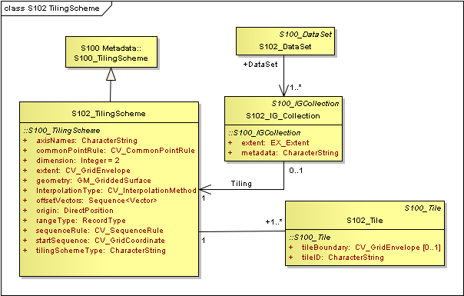

Figure 4.5 - S-102 Tiling Scheme

Table 4.1 provides a description of each attribute of the S102_TilingScheme class attributes.

Table 4.1 - Tiling Scheme description

|  |  |  |  |  |  |
| --- | --- | --- | --- | --- | --- |
| **Role**  **Name** | **Name** | **Description** | **Mult** | **Type** | **Remarks** |
| Class | S102_TilingScheme | Container class for tiling scheme description | - | - |  |
| attribute | tilingSchemeType | description of the type of the tiling scheme | 1 | CharacterString | "uniform quadrilateral grid", or "Quad Tree" or  other |
| attribute | domainExtent | description of the extent of  the tiling scheme | 1 | EX_Extent |  |
| attribute | rangeType | description of the range of the coverage | 1 | RecordType | the record value  for each grid cell in a tiling scheme consists of a single entry corresponding to the tile, |
| attribute | commonPointRule | procedure to be used for evaluating the CV_Coverage at a position that falls on a boundary between tiles or within the boundaries of two or more overlapping tiles | 1 | CV_CommonPointRule | For tiles (not the  data within a tile)  the result is "all". That is, both tiles apply and are returned by a tiling scheme coverage function. The application will determine which  to use. |
| attribute | geometry | geometry of the domain object | 1 | GM_GriddedSurface |  |
| attribute | interpolationType | identification of interpolation method | 1 | CV_InterpolationMethod | not applicable, Tiles cannot be interpolated |
| attribute | dimension | dimensionality of the grid | 1 | Integer | default = 2  No other value is allowed. |
| attribute | axisNames | names of the grid axis | 1 | CharacterString | The grid axis  names are by default "Longitude" and  "Latitude" but may be different if, for example, the grid  is at a different orientation. |
| attribute | origin | position that locates the origin of the rectified grid  in the coordinate reference system | 1 | DirectPosition |  |
| attribute | offsetVectors | a 2 dimensional vector  quantity that determine the grid spacing in each  direction | 1 | Sequence <Vector> |  |
| attribute | extent | description of the extent of the tiling scheme | 1 | CV_GridEnvelope |  |
| attribute | sequenceRule | describe how the grid points are ordered for association to the elements of the sequence values. | 1 | CV_SequenceRule | The default value is "Linear" which  is used for a  uniform quadrilateral grid tile coverage.  No other value is allowed. |
| attribute | startSequence | the grid point to be associated with the first record in the values  sequence | 1 | CV_GridCoordinate | The default value is the lower left corner of the grid |

## Feature Catalogue

### Introduction

The S-102 Feature Catalogue describes the feature types, information types, attributes, attribute values, associations and roles which may be used in the product.

The S-102 Feature Catalogue is available in an XML document which conforms to the S-100 XML Feature Catalogue Schema and can be downloaded from the IHO website.

Note, for Imagery and Gridded Data, a coverage is a type of feature so a product specification may not contain a “catalogue” with the exception of the environmental parameter the dataset models. Therefore much of this clause may be irrelevant.

### Feature Types

S-102 is a coverage feature product. The content information is described in terms of a coverage feature model and a feature catalogue.

A coverage is a type of feature so a Bathymetry Surface Product specification does contain features. There are four coverages defined which along with the associated metadata are the Bathymetry Surface Product Specification. The bathymetry depth coverage and the uncertainty coverage and any optional surface coverage are discrete coverages. The fourth coverage is the discrete point coverage that corresponds to the tracking list of original values and uncertainties. These four entries compose the feature catalogue.

#### Geographic

Geographic (geo) feature types form the principle content of the dataset and are fully defined by their associated attributes and information types.

#### Meta

Meta features contain information about other features within a data set. Information defined by meta features override the default metadata values defined by the data set descriptive records.

Meta features must be used to their maximum extent to reduce meta attribution on individual features.

In S-102 there are no meta features.

### Feature Relationship

A feature relationship links instances of one feature type with instances of the same or a different feature type. There are three common types of feature relationship: Association, Aggregation and Composition.

S-102 uses only one type of feature relationship, : Association..4.3.3.1 Association

An association is used to describe a relationship between two feature types that defines relationships between their instances.

Example: A **S102_IG_Collection** may contain a (0 or 1) **S102_TilingScheme**.

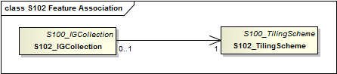

Figure 4.6: Feature Association

### Information Types

Information types are identifiable pieces of information in a dataset that can be shared between other features. They have attributes but have no relationship to any geometry; information types may reference other information types.

### Attributes

The following clauses specify the different types of attributes that may be used in a product specification. They may be either simple or complex.

S-102 defines attributes as either simple or complex.

#### Simple Attributes

Table 4.2 – S-102 Simple Attributes

|  |  |
| --- | --- |
| **Type** | **Definition** |
| Enumeration | A fixed list of valid identifiers of named literal values |
| Boolean | A value representing binary logic. The value can be either *True* or *False*. The default state for Boolean type attributes (i.e. where the attribute is not populated for the feature) is *False*. |
| Real | A signed Real (floating point) number consisting of a mantissa and an exponent |
| Integer | A signed integer number. The representation of an integer is encapsulation and usage dependent. |
| CharacterString | An arbitrary-length sequence of characters including accents and special characters from a repertoire of one of the adopted character sets |
| Date and Time | A DateTime is a combination of a date and a time type. Character encoding of a DateTime must follow ISO 8601:1988  EXAMPLE 19850412T101530 |

#### 

#### Complex Attributes

Complex attributes are aggregations of other attributes that are either simple or complex. The aggregation is defined by means of bindings.

## Dataset Types

### Introduction

Bathymetric Surface datasets are represented as a discrete array of points contained in a regular grid. The general structure for a regular grid is defined in IHO S-100 Part 8.

### Regular Grid

#### S-102 Coverages

The major components of the Bathymetric Surface product are the coverages. At a minimum a Bathymetric Surface product (called a Bathymetric Attributed Grid (BAG)) must have two coverages. The general structure of each is defined in IHO S-100 Part 8 as a georectified grid. Metadata defining the axes, dimensions, and geolocation parameters are found in the metadata in the **MD_GridSpatialRepresentation** and other classes defined in ISO 19115. Furthermore the two coverages are co-located. Each of these contains a two-dimensional matrix organized in row major order, and starting from the south-western most data point, where each value is defined to be at an exactly specified geographic point (or grid node), hence negating the need for horizontal uncertainties

The units of the elevation values are metres, and the sign convention is for z to be positive for values above the vertical datum. The reference vertical datum for the BAG is one of the mandatory Metadata items. This sign convention follows directly from the right hand coordinate system definition to which the standard adheres.

The unknown state for elevation is defined to be 1,000,000.0 (1.0e6).

The uncertainty values are expressed as positive quantities at a node. As detailed in clause 12.2 the uncertainty grid supports multiple definitions of vertical uncertainty. This allows BAGs to span the expected range of data products from raw, full resolution grid to final compiled product. For example, a BAG at the stage of final survey data processing should contain uncertainty information germane to the survey data itself and intended to be used for information compilation. A recipient of a BAG file can refer to the uncertainty definition in the Metadata to gain an understanding of how the uncertainty was computed.

The undetermined state for uncertainty is defined to be 1,000,000.0 (1.0e6).

The values associated with the optional coverages, with the exception of “Nominal Elevation” are expressed as positive quantities at a node. Nominal Elevation is an elevation coverage where the depths would be resolved by a fathometer assuming a sound velocity of 1500 m/sec. The type of parameter associated with the values of an optional coverage are described in clause 4.2.1.1.4.2.

The undetermined state for any optional value is defined to be 1,000,000.0 (1.0e6).

#### Tracking List

The tracking list contains a simple list of the original elevation and uncertainty values from any node of the surface that has been modified to account for hydrographer over-rides of the basic surface definition (e.g., as originally computed by an algorithmic method). The tracking list dataset and corresponding information contained in the metadata exist to provide an audit trail record of changes made to the data by manual intervention.

#### Surface Corrections

The purpose of this optional coverage is to preserve vertical surface corrections. The coverage can have one or more values per point for performing the vertical transformation from the elevation vertical datum to other user-specified datum(s). The optional coverage supports any floating point value, so corrections to other surfaces, like uncertainty, can also be stored in the same coverage. This coverage will likely be sparser than the full resolution grid spacing of the elevation, uncertainty, and other optional data surfaces.

A regularly spaced grid topography or a set of irregularly spaced coordinates, represented as a point coverage, may comprise this dataset. The intended approach is that the S-102 producer provides sufficient data density to allow a simplistic inverse distance interpolation scheme so that correction values can be computed any of the elevation nodes.

#### Extensions

The Bathymetric Surface Product Specification is extensible. This includes both extensions to the content model and to the encodings supporting the content model. Extensions are optional coverages and not required for a file to be qualified nor do they invalidate a compliant product. Additional layers of information not related to the bathymetric scope of this product specification should be defined in separate S.100 and S.10x compliant layers.

## Dataset Types

## In order to facilitate the efficient processing of S-102 data the geographic coverage of a given maximum Display Scale may be split into multiple datasets.

## The discovery or exchange metadata of a dataset must list all extents or the Data Coverage features contained within that dataset and their assigned scale attributions.

## Data Coverage rules

Each S-102 dataset must only have a single extent as it is a coverage feature.

Datasets with the same maximum display scale may overlap, however the set of all extents these datasets must not overlap. This rule applies even if several producers are involved. There must be no overlapping data of the same **maximum Display Scale**, except at the agreed adjoining national data limits, where, it is difficult to achieve a perfect join, a buffer to be agreed to by the national authorities may be used in this situation.

In order to facilitate the efficient processing of S-102 data the geographic coverage of a given **maximum Display Scale** may be split into multiple datasets.

The discovery or exchange metadata of a dataset must list all extents or the **Data Coverage** features contained within that dataset and their assigned scale attributions.

## Dataset Loading and Unloading

A new algorithm based on producer defined dataset display scales (minimum and maximum) for dataset loading and unloading within a navigation system is prescribed in S-102 in order for the appropriate coverage to be viewed at the mariner’s selected viewing scale. This will simplify the process for navigation systems, giving clear and concise rules on how and when data is loaded and unloaded.

### Dataset Loading and Unloading Algorithm

S-102 shall conform to the S-101 dataset loading and unloading algorithm for use within navigation systems. See S-101 ENC Product Specification 0.0.2, clause 4.7.1 - Figure 7, Data Loading and Unloading Algorithm.

## Geometry <S-100 Part 7>

<Geometric representation is the digital description of the spatial component of an object as described in S-100 and ISO 19107. Specify which S-100 Level of Geometry is to be used in the product specification.>

# Coordinate Reference Systems (CRS)

## Introduction

The geo-referencing for a S102 Bathymetric Surface product shall be node-based, referenced from the southwestern-most node in a grid. Each sample in a grid represents the value in the grid at a point location at the coordinate specified, rather than an estimate over any area with respect to the coordinate. The reference position included in the metadata shall be given in the coordinates used for the grid, and shall contain sufficient digits of precision to locate the grid with accuracy no worse than a decimetre on the surface of the ellipsoid of rotation of the chosen horizontal datum.

The Coordinate Reference System information is defined in the manner specified in S-100. The coverage can be specified in any projected coordinate system supported in IHO S-100 Part 6. However, no transformation methods are provided. Note the vertical datum is defined through a second association role to a vertical reference system.

## Spatial Reference System

All coverages in the Bathymetric Surface Product Specification are geo-rectified, simple uniform quadrilateral grids as defined in IHO S-100 Part 8.

All S102 Bathymetric Surface product coverages shall be represented with a right-handed Cartesian coordinate system. This system shall have the x-axis oriented towards positive eastings (for projected grids), or east (for geographic grids), and y-axis oriented towards positive northings (for projected grids), or north (for geographic grids). These definitions imply that the z-axis for the sounding data is positive away from the center of mass of the earth (i.e., is positive up), rather than the usual hydrographic convention of positive down (i.e., deeper depths are larger numbers and negative depths are above datum). User-level code is free to make this reflection if required, but must write the data using the positive-up convention. In order to make this distinction clear, the term ―elevation‖ is used for the vertical component of the BAG, rather than ―depth‖. The uncertainty component of the BAG shall have the same coordinate system as the elevation component, with the exception that the z-axis is unipolar, and therefore the concept of direction of positive increase is irrelevant.

The grid data in a S102 Bathymetric Surface coverage (either elevation or uncertainty, and any other surfaces that may be added) shall be organized as a uniform quadrilateral grid in row-major order from west to east, and south to north Thus, the first sample of the grid is the node at the southwest corner of the grid with location as specified by the geo-referencing parameters, the second is one grid resolution unit to the east of that position and at the same northing or latitude, and the third is two grid resolution units to the east and at the same northing or latitude. For C columns in the grid, the (C+1)th sample in the grid is located one grid resolution unit to the north, but on the same easting, or longitude, as the first sample in the grid.

## Horizontal Coordinate Reference System

For ENC the horizontal CRS must be EPSG: 4326 (WGS84). The full reference to EPSG: 4326 can be found at [www.epsg-registry.org](http://www.epsg-registry.org).

Horizontal Coordinate Reference System: EPSG: 4326 (WGS84)

Projection:  NONE

Temporal reference system: Gregorian Calendar

Coordinate reference system registry: [EPSG Geodetic Parameter Registry](http://www.epsg-registry.org/)

Date type (according to ISO 19115): 002 - publication

Responsible party: International Organisation of Oil and Gas Producers (OGP)

URL: <http://www.ogp.org.uk/>

Coordinate reference system identifier (CRSID):

Code space:

## Vertical Coordinate Reference System

All valid S-102 datasets shall be represented with a right-handed Cartesian coordinate system. This system shall have the x-axis oriented towards positive eastings (for projected grids), or east (for geographic grids), and y-axis oriented towards positive northings (for projected grids), or north (for geographic grids). These definitions imply that the z-axis for the sounding data is positive away from the center of mass of the earth (i.e., is positive up), rather than the usual hydrographic convention of positive down (i.e., deeper depths are larger numbers and negative depths are above datum). User-level code is free to make this reflection if required, but must write the data using the positive-up convention. In order to make this distinction clear, the term “elevation” is used for the sounding component of the BAG, rather than “depth”. The uncertainty component of the BAG shall have the same coordinate system as the elevation component, with the exception that the z-axis is unipolar, and therefore the concept of direction of positive increase is irrelevant.

## Temporal Reference System

The temporal reference system is the Gregorian calendar for date and UTC for time. Time is measured by reference to Calendar dates and Clock time in accordance with ISO 19108:2002, Temporal Schema clause 5.4.4. A date-time variable will have the following 16-character format: *yyyymmddThhmmssZ*.

# Data Quality

As defined in IHO S-100 Part 4c the data quality for the elevation coverage is also defined as a co- located coverage, uncertainty. Uncertainty is defined as the vertical uncertainty at each node location. The uncertainty coverage supports multiple definitions of vertical uncertainty.

# Data Capture and Classification

There are a number of sounding techniques, including SONAR and LIDAR that are used to capture bathymetric data. It is permitted, but not required, to include data acquisition information in the metadata of an S-102 Bathymetric Surface product. The metadata class S102_AcquisitionMetadata has been defined, but the information elements to populate this metadata class should be identified in a national profile of S-102.

# Maintenance

## Maintenance and Update Frequency:

Datasets are maintained by replacement on a tile or dataset basis. That is, the entire data product or tile within a data set including its coverages (elevation/depth, uncertainty, and tracking list point set coverage) and the associated metadata are replaced as a unit. This is unlike S-101 vector data that may be updated incrementally. However, coverage data must be considered as a unit at least at the tile level. This is because processing is done on the entire tile to produce the data product. Any replacement tile will include its own tracking list (when a tracking list is used) to deliberately bias the information for safety of navigation. Also each replacement tile or data set must have its own digital signature.

## Data Source:

Data producers must use applicable sources to maintain and update data and provide a brief description of the sources that were used to produce the dataset.

## Production Process:

Data Producers should follow their established production processes for maintaining and updating datasets.

# Portrayal

## Introduction

This clause describes options for displaying bathymetric surface data as an auxiliary layer with ENC or other S-100 compatible data. Three portrayal options are discussed, and are intended to enhance mariner decision without cluttering the navigation display. S-102 portrayal options:

* Display of soundings extracted from an S-102 dataset.
* Generation and display of S-102 derived depth contours.
* Generation and display of safety contour and associated depth zones

## Display of Soundings Extracted from an S-102 Dataset

Bathymetric surface data products contain discrete grid data values representing depth, and the associated uncertainty of that depth, of the sea or other navigable water way. Through the use of sounding selection and thinning routines, S-100 compliant systems can display a field of soundings extracted directly from the S-102 product.

In addition to extracting and displaying soundings from the S-102 data set, the mariner will have the ability to display associated uncertainty for visible soundings. See clause 9.3.2 for additional information.

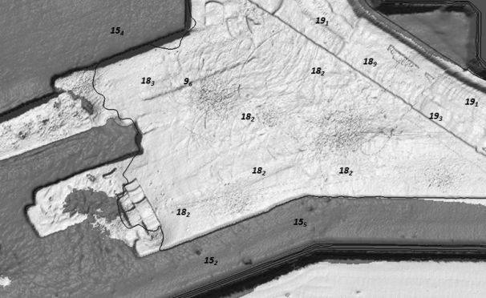

Figure 9.1 – Display of S-102 Extracted Soundings

### Sounding Selection and Display Parameters

The selection and display of soundings will take place within the ECDIS. See IHO S-4 Chart Specifications, Clause 400 Representation of Depth: General, B-412 Soundings for guidance.

### Numerical display of Associated Uncertainty

Uncertainty information, while not immediately visible to the mariner, can be temporally visualized by placing the cursor over visible soundings extracted from S-102 data. If the sounding is selected, the associated uncertainty will remain displayed until another sounding is selected. Uncertainty information will be displayed as black text inside a white box (zero transparency) with a black border (1 pixel line thickness).

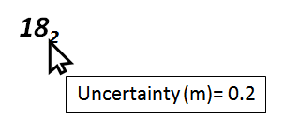

Figure 9.2 – Display of uncertainty by cursor selection.

**9.3 Generation and Display of S-102 Derived Depth Contours**

In nautical charting a depth contour connects points of equal elevation below chart datum. Depth contours have traditionally been generated by the charting authority at time of chart compilation. With the addition of S-102 the ECDIS has the ability to generate and display enhanced depth contours using mariner provided context parameters. This capability exists within extents of an S-102 dataset.

The creation of S-100 compliant contours is a three-step process involving surface generalization, contour creation, followed by feature designation. Clauses 9.4.1 and 9.4.2 provide a high level description on surface generalization and contour creation.

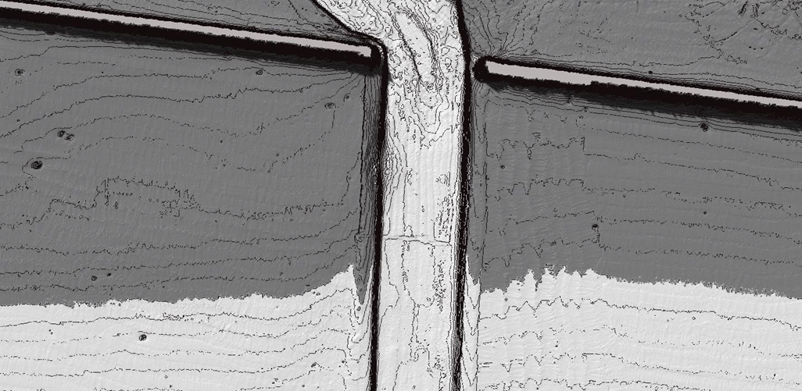

Figure 9.3 – S-102 Enhanced Contours

**9.3.1 Pre-Depth Curve Generation - Generalization of S-102 Dataset**

S-102 datasets are gridded at pre-defined resolutions to support specific ENC libraries (see Table 1, Minimum Display and Maximum Display Scales with Corresponding Grid Size). While these datasets cannot be used to in conjunction with larger scale charting products, the surface can be generalized to support navigation with smaller scale ENC libraries. While surface generalization results in a coarser gridded dataset, it is important to note that the process described in Annex G preserves all shoal depths including any hydrographer designated soundings.

All surface generalization must conform to the resolutions defined in table 1.

See Annex G for more detailed information on this process.

**9.3.2 Depth Contour Generation**

See IHO S-4 Chart Specifications, Clause 400 Representation of Depth: General, B-411 Depth Contours and Shallow Water Tint, for guidance on creating depth contours.

**9.3.3 Contour Feature Designation**

S-102 derived depth contours are single coded thick lines, conforming to the following colour token for chart display.

|  |  |  |
| --- | --- | --- |
| **Usage** | **Colour Token** | **Colour**  **(Day/Dusk/Night)** |
| Depth Contour | DEPCN | Grey |

Table 9.1 Depth Contour Colour Token

## 9.4 Generation and Display of Safety Contour and Associated Depth Zones

S-101 product specifications state that the mariner has the ability to define own-ship safety contour, selected from among displayed contours in the SENC. The addition of an S-102 dataset enhances this capability, providing means to render and display the safety contour and associated depth zones directly from the grid.

As S-102 data is ingested the ECDIS will perform two operations using the current value for safety contour: 1) delineation and display of depth zones shades, and 2) generation of a safety contour. The functionality defined below will only exist within the extents of the S-102 dataset.

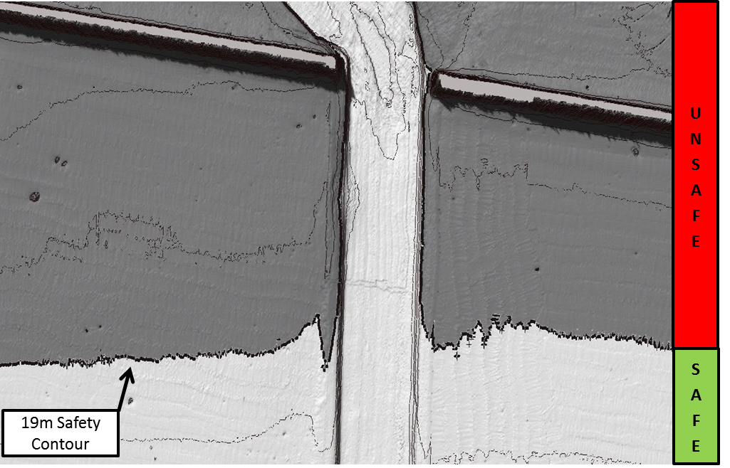

Figure 9.4 – Display of Safety Contour w/ Depth Zones (1m contours)

**9.4.1 Gridded Dataset Visualization**

The mariner will have the option to visualize S-102 data as a sun-illuminated or static (flat) surface. The depiction of sun-illumination requires the entry of a sun azimuth and corresponding elevation. Recommended values for sun azimuth angle and elevation defined in Table 9.X.

|  |  |  |
| --- | --- | --- |
| **Attribute** | **Value in Degrees** | |
| **Sun-Illuminated** | **Flat Surface** |
| Sun Azimuth Angle | 315 Degrees | 0.0 Degrees |
| Sun Elevation | 15 Degrees | 0.0 Degrees |

Table 9.2 – Sun Azimuth and Elevation Values

**9.4.2 Depth Zone Shading**

S-101 product specification, clause C2.3.8.2, discusses how depth zone shades are defined by the safety contour. The addition of S-102 data enhances this capability. Using the mariner defined or default safety contour value (30m), S-102 can be coloured to represent the following zones.

|  |  |  |  |
| --- | --- | --- | --- |
| **Depth Zone** | **Description** | **Colour Token** | **Colour**  **(Day/Dusk/Night)** |
| Deep Water | deeper than the selected safety contour | DEPDW | White/Black |
| Shallow Water | shallower than the selected safety contour | DEPVS | Medium/Light Blue |

Table 9.3 – Deep and Shallow Depth Zones.

**9.4.3 Generation of Safety Contour from S-102 Data**

As discussed in clause 9.4, the addition of an S-102 dataset provides the ability to generate and display S-100 compliant contours. This capability includes the generation of a safety contour as defined by the mariner’s own-ship safety contour value or an ECDIS default safety contour value (30m).

See IHO S-4 Chart Specifications, Clause 400 Representation of Depth: General, B-411 Depth Contours and Shallow Water Tint, for guidance on creating depth contours.

**9.4.4 Safety Contour Feature Designation**

An S-102 derived safety contour is double-coded by a thick line and conforms to the following colour token for chart display.

|  |  |  |
| --- | --- | --- |
| **Usage** | **Colour Token** | **Colour**  **(Day/Dusk/Night)** |
| Safety Contour | DEPSC | Grey |

Table 9.4 Safety Contour Colour Token

**9.4.5 Transparency**

S-102 dataset transparency must be adjusted to match current S-101 display settings (Table 9.X). The level of opaqueness is represented by the value alpha. A value of 1 represents zero transparency. A value of 0 represents 100% transparency.

|  |  |
| --- | --- |
| **ENC Display Setting** | **Alpha** |
| ENC Day | 1 |
| ENC Dusk | 0.4 |
| ENC Night | 0.2 |

Table 9.5 – Transparency values for S-102 Dataset

**9.4 .6 Numerical Display of Grid Node Depth and Associated Uncertainty**

Grid node depth and associated uncertainty, while not immediately visible, can be temporally visualized by placing the cursor over individual grid nodes of the S-102 dataset. Nodal information will be displayed as black text inside a white box (zero transparency) with a black border (1 pixel line thickness).

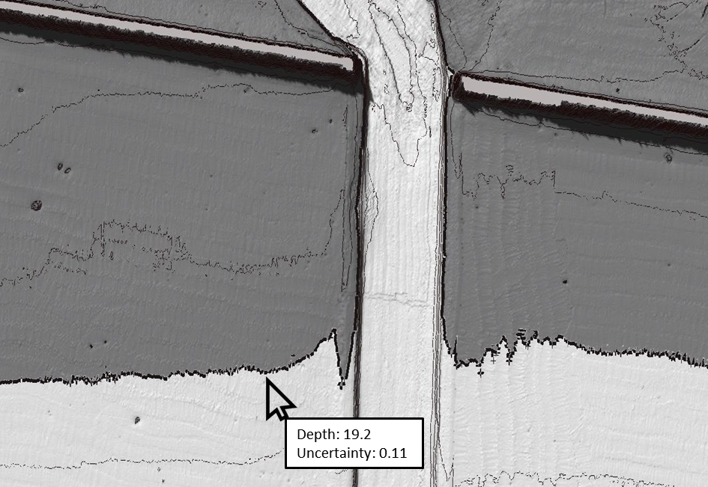

Figure 9.5 – Display of Grid Node Depth and Associated Uncertainty

# Data Product format (encoding)

## Introduction

The S-102 data set must be encoded using the Hierarchical Data Format standard, Version 5 (HDF5).

Format Name: HDF-5

Version: 1.8

Character Set: UTF-8

Specification: <https://www.hdf5group.org>

# Data Product Delivery

## Introduction

This clause describes how S-102 data will be delivered from the charting authority to the mariner.

Units of Delivery: Exchange Set

Transfer Size: 10 to 256 MB, see clause 11.2.1.1.

Medium Name: Digital Data Delivery

Other Delivery Information:

Each dataset must be contained in a physically separate, uniquely identified file on the transfer medium.

Each exchange set has a single exchange catalogue which contains the discovery metadata for each dataset and references to any support files.

An exchange set is encapsulated into a form suitable for transmission by a mapping called an encoding. An encoding translates each of the elements of the exchange set into a logical form suitable for writing to media and for transmission online. An encoding may also define other elements in addition to the exchange set contents (This is media identification, data extents etc…) and also may define commercial constructs such as encryption and compression methods.

If the data is transformed in S-102 it must not be changed.

This product specification defines the encoding which must be used as a default for transmission of data between parties.

The encoding encapsulates exchange set elements as follows:

**Mandatory Elements**

* S-102 datasets – HDF encoding
* Exchange Catalogue – the XML encoded representation of exchange set catalogue features [discovery metadata].

**Optional Elements**

* S-102 Feature Catalogue – If it is necessary to deliver the latest feature catalogue to the end user it may be done using the S-102 exchange set mechanism for datasets
* S-102 Portrayal Catalogue - If it is necessary to deliver the latest portrayal catalogue to the end user it may be done using the S-102 exchange set mechanism for datasets.

## Dataset

### Datasets

Two types of dataset files may be produced and contained within an exchange set:

* New dataset and new edition of a dataset (base dataset): Including new information which has not been previously distributed by updates. Each new edition of a dataset must have the same name as the dataset that it replaces.
* Cancellation: The dataset is cancelled and is deleted from the system.

#### Dataset size

#### Multiple delivery options exist including wireless transfer to platform and/or pier-side data transfer. The following file size limits are recommended for these options:

#### Datasets must not exceed 10MB for transmission (wireless to platform).

Datasets must not exceed 256 MB for physical media transfer to platform.

### Dataset file naming

*CCXXXXXXXX.EEE*

The file name forms a unique identifier where:

* CC - the first two characters identify the issuing agency (mandatory).
* the third to tenth characters are optional and may be used in any way by the producer to provide the unique file name. The following characters are allowed in the dataset name, A to Z, 0 to 9 and the special character _ (underscore).
* .EEE – new editions use 102 (mandatory).
* the maximum number of characters is ten.

## Support Files

This Data Product requires no support files.

### Support File Naming

This Data Product requires no support files.

## Exchange Catalogue

The exchange catalogue acts as the table of contents for the exchange set. The catalogue file of the exchange set must be named S102ed1.CAT. No other file in the exchange set may be named S102ed1.CAT. The contents of the exchange catalogue are described in Clause 12.

# Metadata

## Introduction

The Metadata elements used in the Bathymetric Surface product are derived from S-100 and from ISO 19115 and ISO 19115-2. Optionally additional metadata may be derived from ISO 19130 and ISO 19130-22 especially metadata relating to the SONAR equipment which may have been used to acquire the bathymetric data.

There are only a few elements in the ISO 19115 metadata standard that are mandatory and these relate only to the use of the metadata for identification and pedigree of the data set. A minimum level of data identification is required for all applications including database applications, web services and data set production. However, S-102 requires certain metadata attributes which are used to geolocate the dataset as well as lineage attribution which define processes used to establish the tracking list and establish a pedigree for the data.

The elements are related in a metadata schema, and include definitions and extension procedures. There exist both mandatory and conditional metadata elements. Only a few metadata elements are mandatory but the inclusion of some of the optional metadata elements establish a situation where other metadata elements are conditionally made mandatory.

The following table outlines the core metadata elements (mandatory and recommended optional) required for describing a geographic information data set. The codes indicate: "M" mandatory, "O" optional' "C" conditional as defined in ISO 19115. The table indicates how the mandatory, optional and conditional core metadata are handled in S-102.

Table 12.1 – S-102 Handling of Core Metadata Elements

|  |  |
| --- | --- |
| **Dataset title** (M)  S102_DS_DiscoveryMetadata > citation > CI_Citation.title  from: (MD_Metadata > MD_DataIdentification.citation > CI_Citation.title) | **Spatial representation type** (O)  S102_DS_DiscoveryMetadata > spatialRepresentationType : MD_ SpatialRepresentationType Code  002– Grid; (for quadrilateral grid coverage)  001– Vector; (for tracking list discrete point coverage)  from: (MD_Metadata > MD_DataIdentification.spatialRepresentationType) |
| **Dataset reference date** (M)  S102_DS_DiscoveryMetadata > citation > CI_Citation.date  from: (MD_Metadata > MD_DataIdentification.citation > CI_Citation.date) | **Reference system** (O) S102_StructureMetadataBlock > hRefSystem and S102_StructureMetadataBlock > vRefSystem  from: (MD_Metadata > MD_ReferenceSystem) |
| **Dataset responsible party** (O)  S102_DS_DiscoveryMetadata >  pointOfContact > CI_ ResponsibleParty  from: (MD_Metadata > MD_DataIdentification.pointOfContact > CI_ResponsibleParty) | **Lineage** (C)  S102_QualityMetadataBlock > S102_LI_Source and  S102_QualityMetadataBlock > S102_LI_ProcessStep  from: (MD_Metadata > DQ_DataQuality.lineage > LI_Lineage) |
| **Geographic location of the dataset (by four coordinates or by geographic identifier)** (C)  S102_DS_DiscoveryMetadata > extent > EX_Extent  from: (MD_Metadata > MD_DataIdentification.extent > EX_Extent > EX_GeographicExtent > EX_GeographicBoundingBox or EX_GeographicDescription ) | **On-line resource** (O)  (MD_Metadata > MD_Distribution > MD_DigitalTransferOption.onLine > CI_OnlineResource)  Optional - not required |
| **Dataset language** (M)  S102_DS_DiscoveryMetadata > language from: (MD_Metadata >  MD_DataIdentification.language) | **Metadata file identifier** (O)  (MD_Metadata.fileIdentifier)  Implicit in S-102 product specification reference to ISO  19115 as a normative reference |
| **Dataset character set** (C)  set to default = "utf8". [not required when set to default from ISO 19115]  from: (MD_Metadata > MD_DataIdentification.characterSet) | **Metadata standard name** (O)  (MD_Metadata.metadataStandardName)  Implicit in S-102 product specification reference to ISO  19115 as a normative reference |
| **Dataset topic category** (M)  S102_DS_DiscoveryMetadata >  topicCategory: MD_TopicCategoryCode  006– elevation;  012– oceans;  014– inlandWaters  [see clause 8.5]  from: (MD_Metadata > MD_DataIdentification.topicCategory) | **Metadata standard version** (O)  (MD_Metadata.metadataStandardVersion)  Implicit in S-102 product specification reference to ISO  19115 as a normative reference |
| **Spatial resolution of the dataset**  (O)  (MD_Metadata > MD_DataIdentification.spatialResolution > MD_Resolution.equivalentScale or MD_Resolution.distance)  Since this data set is a grid coverage resolution is defined by the coveraqe grid parameters. | **Metadata language** (C)  (MD_Metadata.language)  The language is set to English. In addition additional languages may be used in accordance with the structure for handling multi-languages per ISO 19115  Annex J. |
| **Abstract describing the dataset**  (M)  S102_DS_DiscoveryMetadata > abstract from: (MD_Metadata >  MD_DataIdentification.abstract) | **Metadata character set** (C)  set to default = "utf8". [not required when set to default from ISO 19115]  from: (MD_Metadata.characterSet) |
| **Distribution format** (O)  (MD_Metadata > MD_Distribution > MD_Format.name and MD_Format.version)  Optional - not applicable  to maintain the separation of carrier and content the content model does not contain any format information. This would be included in a transmittal or by file types. | **Metadata point of contact** (M)  S102_DS_DiscoveryMetadata > contact  from: (MD_Metadata.contact > CI_ResponsibleParty) |
| **Additional extent information for the dataset (vertical and temporal)** (O)  (MD_Metadata > MD_DataIdentification.extent > EX_Extent > EX_TemporalExtent or EX_VerticalExtent)  Optional - not required | **Metadata date stamp** (M) S102_DS_DiscoveryMetadata > dateStamp from: (MD_Metadata.dateStamp) |

## Discovery Metadata

Metadata is used for a number of purposes. One high level purpose is for the identification and discovery of data. Every data set needs to be identified so that it can be distinguished from other data sets and so it can be found in a data catalogue, such as a Web Catalogue Service. The discovery metadata applies at the **S102_DataSet** level and at the **S102_IG_Collection** level. That is, there is discovery data for the whole data set and for those data sets that are composed of several tiles there is also equivalent discovery metadata for each tile.

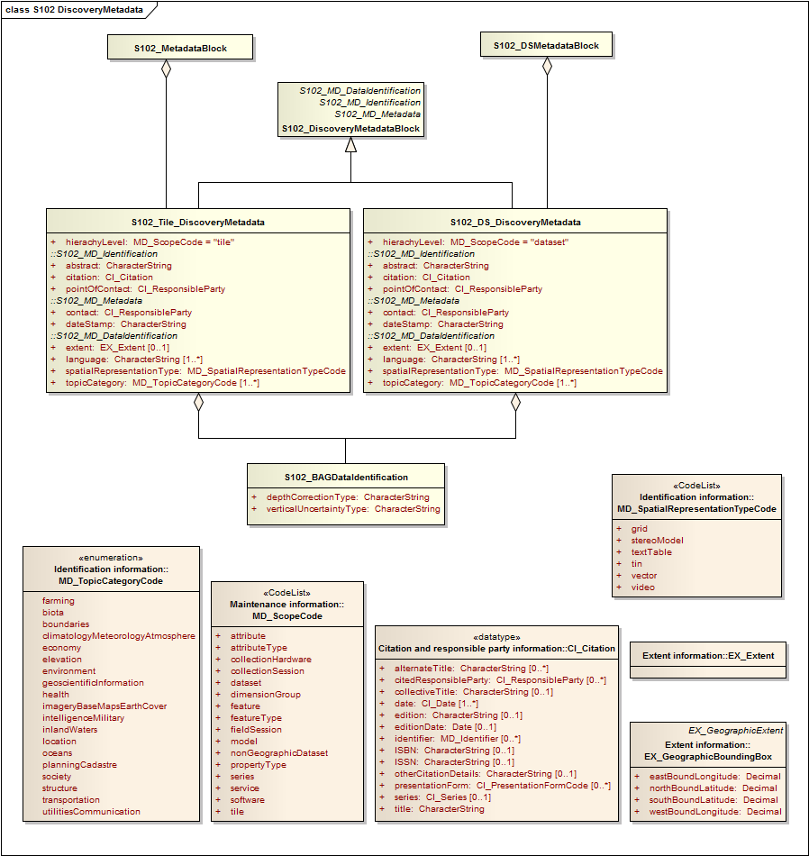

Figure 12.1 – S-102 Discovery Metadata

Figure 12.1 shows the **S102_DiscoveryMetadataBlock**. It has two subtypes S102_DS_DiscoveryMetadata and **S102_Tile_DiscoveryMetadata**. The only difference is that the *hierachyLevel* code is set to "dataset" for the whole data set and "tile" for a tile. These two classes implement the metadata classes from ISO 19115. First implementation classes have been developed corresponding to each of the ISO 19115 classes that have been referenced in which only the applicable attributes have been included. The classes **S102_DS_DiscoveryMetadata** and **S102_Tile_DiscoveryMetadata** inherit their attributes from these S-102 specific implementation classes. In addition an additional component **S102_BAGDataIdentification** has been added.

This model provides the minimum amount of metadata for a Bathymetry Surface data product. Any of the additional optional metadata elements from the source ISO 19115 metadata standard can also be included.

Table 12.2 provides a description of each attribute of the S102_DiscoveryMetadataBlock class attributes.

Table 12.2 - S102_DiscoveryMetadataBlock class attributes.

|  |  |  |  |  |  |
| --- | --- | --- | --- | --- | --- |
| **Role**  **Name** | **Name** | **Description** | **Cardinality** | **Type** | **Remarks** |
| Class | S102_DiscoveryMetadata  Block | Container class for  discovery metadata | - | - |  |
| Class | S102_DS_DiscoveryMeta data | Container class for  discovery metadata related to an entire data set | - | - |  |
| Class | S102_Tile_DiscoveryMeta data | Container class for  discovery metadata related to a particular tile  when there are multiple  tiles in a data set. | - | - |  |
| attribute | hierachyLevel |  | 1 | MD_ScopeCode | "dataset" for  S102_DS_Discov eryMetadata or  "tile" for  S102_Tile_Discov eryMetadata |
| attribute | contact | party responsible for the  metadata information | 1 | CI_ResponsibleParty |  |
| attribute | dateStamp | date that the metadata  was created | 1 | CharacterString |  |
| attribute | abstract | brief narrative summary of the  content of the resource(s) | 1 | CharacterString |  |
| attribute | citation | citation data for the resource(s) | 1 | CI_Citation | CI_Citation  <<DataType>> Required items  are Citation.title, & Citation.date, |
| attribute | pointOfContact | identification of, and  means of communication with,  person(s) and organization(s) associated  with the resource(s) | 1 | CI_ResponsibleParty | CI_ResponsibleP  arty  <<DataType>> |
| attribute | language | language(s) used within the  dataset | 1-* | CharacterString | ISO 639-2 list of languages, default "English" plus  others as used. |
| attribute | topicCategory | main theme(s) of the dataset | 1-* | MD_TopicCategoryCode | MD_TopicCategor  yCode  <<Enumeration>>  006– elevation;  012– oceans;  014–  inlandWaters |
| attribute | extent | extent information including the  bounding box, bounding  polygon,  vertical, and temporal extent of the  dataset | 0-1 | EX_Extent | EX_Extent  <<DataType>> |
| attribute | spatialRepresentationType | method used to spatially represent  geographic information | 1 | MD_SpatialRepresentati onTypeCode | MD_SpatialRepre  sentation  TypeCode  <<CodeList>>  002– Grid; (for quadrilateral grid coverage)  001– Vector; (for tracking list discrete point  coverage) |
| Class | S102_BAGDataIdentificati on | component for  S102_DiscoveryMetadata  Block. Extension beyond  ISO 19115 metadata | - | - |  |
| attribute | depthCorrectionType | code defining the type of sound velocity correction made to the depths | 1 | CharacterString | see table 4 |
| attribute | verticalUncertaintyType | code defining how  uncertainty was determined | 1 | CharacterString | see table 5 |

The class **S102_BAGDataIdentification** provides an extension to the metadata available from ISO 19115. The verticalUncertaintyType attribute was added to allow the BAG to accurately describe the source and meaning of the encoded Uncertainty coverage. The depthCorrectionType was also added to define if and how the elevations are corrected (i.e. true depth, depth ref 1500 m/sec, etc.). Tables 12.3 and 12.4 provide a description.

Table 12.3 - Code defining the type of sound velocity correction

|  |  |
| --- | --- |
| **Value** | **Definition** |
| SVP_Applied | Sound velocity field measured and applied (True Depth). |
| 1500_MS | Assumed sound velocity of 1500 m/s used. |
| 1463_MS | Assumed sound velocity of 1463.04 m/s used (Equivalent to 4800 ft/s). |
| NA | Depth not measured acoustically. |
| Carters | Depths corrected using Carter‘s Tables. |
| Unknown |  |

Table 12.4 - Code defining how uncertainty was determined

|  |  |
| --- | --- |
| **Value** | **Definition** |
| Unknown | "Unknown" - The uncertainty layer is an unknown type |
| Raw_Std_Dev | "Raw Standard Deviation" - Raw standard deviation of  soundings that contributed to the node. |
| CUBE_Std_Dev | Dev "CUBE Standard Deviation " - Standard deviation of soundings captured by a  CUBE hypothesis (i.e., CUBE‘s standard output of uncertainty) |
| Product_Uncert | "Product Uncertainty" - NOAA standard product uncertainty  V1.0 (a blend of CUBE uncertainty and other measures). |
| Historical_Std_Dev | "Historical Standard Deviation " – Estimated standard deviation based on  historical/archive data. |

## Structure Metadata

Structure metadata is used to describe the structure of an instance of a collection, including any reference to a tiling scheme. Since constraints can be different on separate files (for example they could be derived from different legal sources), or security constraints may be different, the constraint information becomes part of the structure metadata. The other structure metadata is the grid representation and the reference system.

Figure 12.2 shows the **S102_StructureMetadataBlock**. The metadata block is generated by the inheritance of attributes from a number of ISO 19115 metadata classes, and S-100 class for tiling and two implementation classes for the horizontal and vertical reference system. This makes the metadata block a simple table.

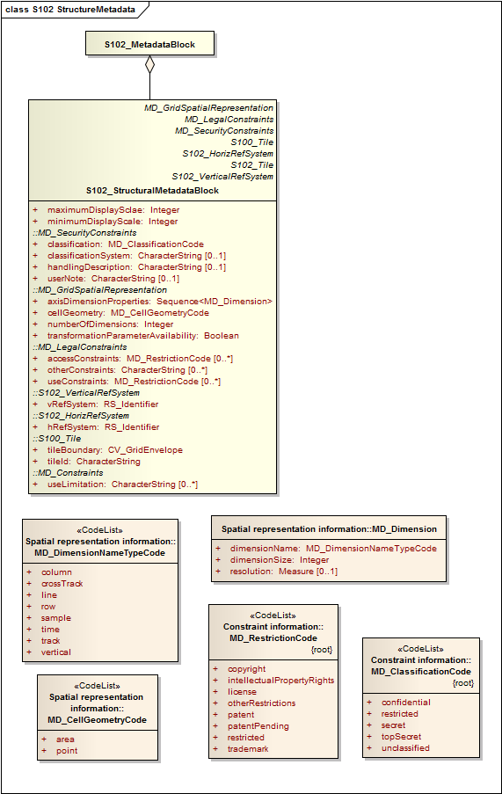

Figure 12.2 – S-102 Structure Metadata

Table 12.5 provides a description of each attribute of the **S102_StructureMetadataBlock** class attributes.

Table 12.5 - S102_StructureMetadataBlock class attributes.

|  |  |  |  |  |  |
| --- | --- | --- | --- | --- | --- |
| **Role**  **Name** | **Name** | **Description** | **Cardina lity** | **Type** | **Remarks** |
| Class | S102_StructuralMetadata  Block | Container class for  structural metadata | - | - |  |
| attribute | maximumDisplayScale | Maximum display scale for the elevation coverage. | 1 | Integer |  |
| attribute | minimumDisplayScale | Minimum display scale for the elevation coverage. | 1 | Integer |  |
| attribute | numberOfDimensions | number of independent  spatialtemporal axes | 1 | Integer | default = 2  No other value is allowed. |
| attribute | axisDimensionProperties | information about spatial- temporal  axis properties | 1 | MD_Dimension | MD_Dimension  <<DataType>>  dimensionName and  dimensionSize |
| attribute | cellGeometry | identification of grid data as point or cell | 1 | MD_CellGeometryCode | MD_CellGeometry  Code  default = point  No other value is allowed. |
| attribute | transformationParameterA  vailability | indication of whether or  not parameters for transformation between image coordinates and geographic or map coordinates  exist (are available) | 1 | Boolean | 1 = yes 0 = no Mandatory and must be 1. |
| attribute | vRefSystem | name of vertical reference system | 1 | RS_Identifier | reference system vertical  information, can also be defined explicitly by use of  the parameters in  19111 |
| attribute | hRefSystem | name of horizontal reference system | 1 | RS_Identifier | default = WGS84. reference system horizontal  information, can also be defined explicitly by use of  the parameters in  19111. |
| attribute | accessConstraints | Access constraints applied to assure the protection of privacy or intellectual  property, and any special restrictions or limitations on obtaining the dataset. | 0-* | MD_RestrictionCode |  |
| attribute | useConstraints | Constraints applied to assure the protection of privacy or intellectual  property, and any special restrictions or limitations or warnings on using the  dataset | 0-* | MD_RestrictionCode |  |
| attribute | otherConstraints | Other restrictions and  legal prerequisites for accessing and using the dataset | 0-* | CharacterString |  |
| attribute | classification | Name of the handling  restrictions on the dataset | 1 | MD_ClassificationCode |  |
| attribute | userNote | Additional information  about the classification | 0-1 | CharacterString |  |
| attribute | classificationSystem | Name of the classification  system | 0-1 | CharacterString |  |
| attribute | handlingDescription | Additional information  about the restrictions on handling the dataset | 0-1 | CharacterString |  |
| attribute | tileID | tile identifier | 1 | CharacterString |  |
| attribute | tileBoundary | tile boundary | 0-1 | GM_Curve | When not provided is assumed to be the extent of the collection asdefined by EX_Extent |
| Class | MD_Dimension | Axis properties | - | - |  |
| attribute | dimensionName | name of axis | 1 | MD_DimensionTypeCod e | Defaults are "row" and "column" Not other value is allowed. |
| attribute | dimensionSize | number of elements along the axis | 1 | Integer |  |
| attribute | resolution | degree of detail in the grid dataset | 0-1 | Measure | value= number |

### Quality Metadata

Quality metadata is used to describe the quality of the data in an instance of a collection. Figure 7 shows the **S102_QualityMetadataBlock**. The **S102_QualityMetadataBlock** derives directly from the ISO 19115 class **DQ_DataQuality**. However its components **S102_LI_Source** and **S102_LI_ProcessStep** are generated by the inheritance of attributes from the ISO 19115 classes **LI_Scope** and **LI_ProcessStep**. Only some of the attributes of the referenced ISO 19115 classes are implemented. In addition the class **S102_Bag_ProcessStep** has been added. This extension allows internal Tracking List entries to be associated with a unique entry in the metadata so that the changes can be properly attributed, described and easily referenced.

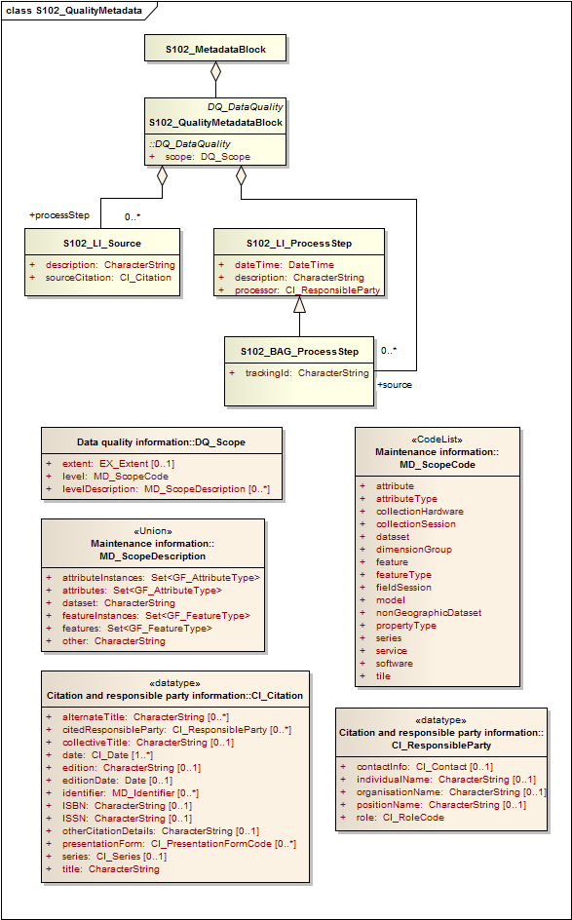

Figure 12.3 S-102 Quality Metadata

Table 12.6 provides a description of each attribute of the S102_QualityMetadataBlock class attributes and those of its components.

Table 12.6 - Quality Metadata Block description

|  |  |  |  |  |  |
| --- | --- | --- | --- | --- | --- |
| **Role**  **Name** | **Name** | **Description** | **Cardinality** | **Type** | **Remarks** |
| Class | S102_QualityMetadataBlock | Container class for quality  metadata | - | - |  |
| attribute | scope | extent of characteristic(s)  of the  data for which quality information  is reported | 1 | DQ_Scope |  |
| Class | S102_LI_Source | information about the  source data  used in creating the data specified  by the scope | - | - |  |
| attribute | description | detailed description of the  level of  the source data | 1 | CharacterString |  |
| attribute | sourceCitation | recommended reference  to be used for the source data | 1 | CI_Citation |  |
| Class | S102_LI_ProcessStep | information about an event or transformation in the life of a dataset including the  process used to maintain the dataset | - | - |  |
| attribute | dateTime | date and time or range of date and  time on or over which the  process  step occurred | 1 | CharacterString |  |
| attribute | description | description of the event, including  related parameters or  tolerances | 1 | CharacterString |  |
| attribute | processor | identification of, and  means of communication with,  person(s) and organization(s) associated  with the process step | 1 | CI_ResponsibleParty |  |
| Class | S102_BAG_ProcessStep | Management of TrackingList references to LI_ProcessStep | - | - |  |
| attribute | trackingId | ID reference used so that  Tracking List entries can be associated with a  unique entry in the metadata so that the  changes can be properly attributed, described and easily referenced | 1 | CharacterString |  |
| Class | DQ_Scope | Container class for quality  metadata | - | - |  |
| attribute | level | hierarchical level of the  data  specified by the scope | 0-* | MD_ScopeCode  <<CodeList>> | "dataset" or "tile" |
| attribute | extent | information about the  horizontal,  vertical and temporal extent of the  data specified by the  scope | 0-* | EX_Extent  <<DataType>> | Used only if the extent of the data is different from the EX_Extent given for the collection / tile |
| attribute | levelDescription | detailed description about the level  of the data specified by  the scope | 1 | MD_ScopeDescription  <<Union>> |  |

### Acquisition Metadata

Acquisition metadata to a Bathymetric Surface Product Specification profile that they are developing nationally. The classes derive from ISO 19115, 19115-2, 19130 and 19130-2. The later document 19130-2 contains description of SONAR parameters.

## Exchange Set Metadata

For information exchange, there are several categories of metadata required: metadata about the overall exchange catalogue, metadata about each of the datasets contained in the catalogue, and metadata about the support files that make up the package.

Figures 12.4 to 12.7 outline the overall concept of an S-102 exchange set for the interchange of geospatial data and its relevant metadata. Figure 12.4 depicts the realization of the ISO 19139 classes which form the foundation of the exchange set. The overall structure of S-102 metadata for exchange sets is modelled in Figures 12.5 and 12.6. More detailed information about the various classes is shown in Figure 12.7 and a textual description in the tables at clause 12.6.

The discovery metadata classes have numerous attributes which enable important information about the datasets and accompanying support files to be examined without the need to process the data, for example, decrypt, decompress, load etc. Other catalogues can be included in the exchange set in support of the datasets such as feature and portrayal. The attribute “purpose” of the support file metadata provides a mechanism to update support files more easily.

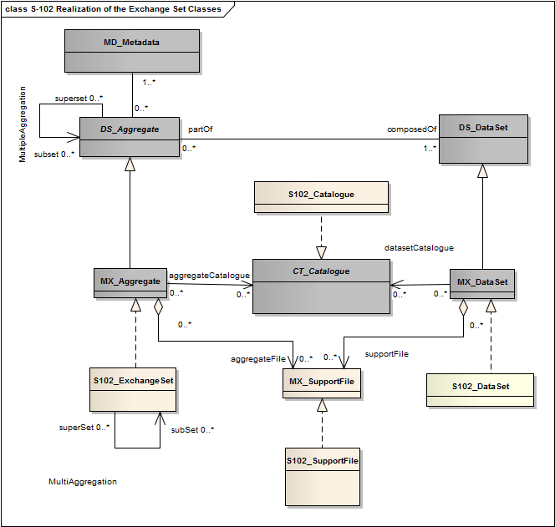

Figure 12.4 Realization of the Exchange Set Classes

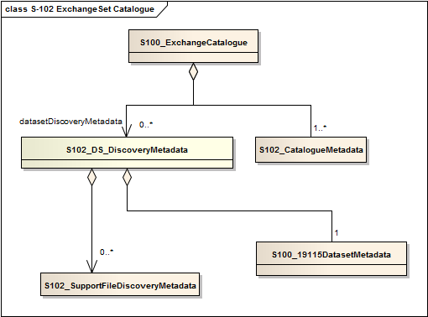

Figure 12.5 – S-102 ExchangeSet Catalogue

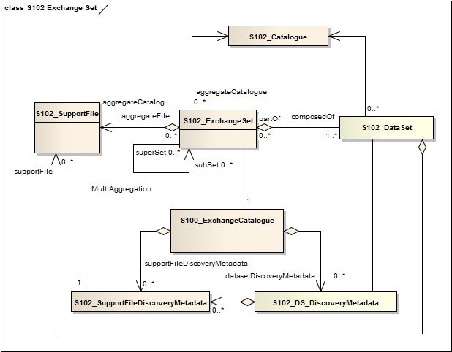

Figure 12.6 - S-102 Exchange Set

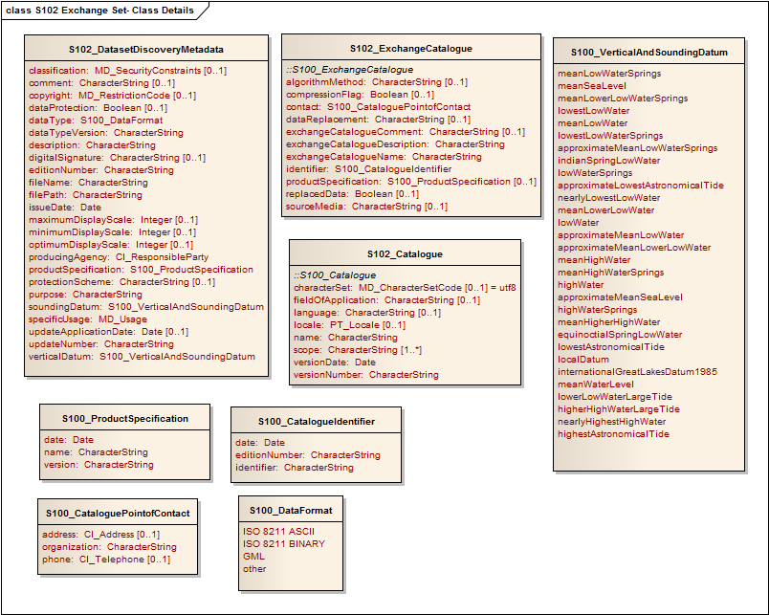

Figure 12.7 S-102 Exchange Set - Class Details

The following clauses define the mandatory and optional metadata needed for S-102. In some cases the metadata may be repeated in a national language. If this is the case it is noted in the Remarks column.

## Language

The exchange language must be English. Other languages may be used as a supplementary option. National geographic names can be left in their original national language using the complex attribute Feature Name.

Character strings must be encoded using the character set defined in ISO 10646-1, in Unicode Transformation Format-8 (UTF-8). A BOM (byte order mark) must not be used.

## S102_ExchangeCatalogue

Each exchange set has a single S100_ExchangeCatalogue which contains meta information for the data and support files in the exchange set.

|  |  |  |  |  |
| --- | --- | --- | --- | --- |
| **Name** | **Description** | **Mult** | **Type** | **Remarks** |
| S100_ExchangeCatalogue | An exchange catalogue contains the discovery metadata about the exchange datasets and support files | - | - | - |
| identifier | Uniquely identifies this exchange catalogue | 1 | S100_CatalogueIdentifier |  |
| contact | Details about the issuer of this exchange catalogue | 1 | S100_CataloguePointOfContact |  |
| productSpecification | Details about the product specifications used for the datasets contained in the exchange catalogue | 0..1 | S100_ProductSpecification | Conditional on all the datasets using the same product specification |
| metadataLanguage | Details about the Language | 1 | CharacterString |  |
| exchangeCatalogueName | Catalogue filename | 1 | CharacterString | In S-101 it would be CATLOG.101 |
| exchangeCatalogueDescription | Description of what the exchange catalogue contains | 1 | CharacterString |  |
| exchangeCatalogueComment | Any additional Information | 0..1 | CharacterString |  |
| compressionFlag | Is the data compressed | 0..1 | Boolean | Yes or No |
| algorithmMethod | Type of compression algorithm | 0..1 | CharacterString | Eg. RAR or ZIP |
| sourceMedia | Distribution media | 0..1 | CharacterString |  |
| replacedData | If a data file is cancelled is it replaced by another data file | 0..1 | Boolean |  |
| dataReplacement | Cell name | 0..1 | CharacterString |  |

### S102_CatalogueIdentifier

|  |  |  |  |  |
| --- | --- | --- | --- | --- |
| **Name** | **Description** | **Mult** | **Type** | **Remarks** |
| S100_CatalogueIdentifier | An exchange catalogue contains the discovery metadata about the exchange datasets and support files | - | - | - |
| identifier | Uniquely identifies this exchange catalogue | 1 | CharacterString |  |
| editionNumber | The edition number of this exchange catalogue | 1 | CharacterString |  |
| date | Creation date of the exchange catalogue | 1 | Date |  |

### S102_CataloguePointofContact

|  |  |  |  |  |  |
| --- | --- | --- | --- | --- | --- |
| **Name** | **Description** | **Mult** | **Type** | | **Remarks** |
| S100_CataloguePointOfContact | Contact details of the issuer of this exchange catalogue | - | | - | - |
| organization | The organization distributing this exchange catalogue | 1 | | CharacterString | This could be an individual producer, value added reseller, etc. |
| phone | The phone number of the organization | 0..1 | | CI_Telephone |  |
| address | The address of the organization | 0..1 | | CI_Address |  |

## S102_DatasetDiscoveryMetaData

| **Name** | **Description** | **Mult** | **Type** | **Remarks** |
| --- | --- | --- | --- | --- |
| S100_DatasetDiscoveryMetadata | Metadata about the individual datasets in the exchange catalogue | - | - | - |
| fileName | Dataset file name | 1 | CharacterString | Dataset file name according to format defined in clause 11.2.2.  CCXXXXXXXX.EEE |
| filePath | Full path from the exchange set root directory | 1 | CharacterString | Path relative to the root directory of the exchange set. The location of the file after the exchange set is unpacked into directory <EXCH_ROOT> will be <EXCH_ROOT>/<filePath>/<filename> |
| description | Short description giving the area or location covered by the dataset | 1 | CharacterString | E.g. a harbour or port name, between two named locations etc. |
| dataProtection | Indicates if the data is encrypted | 0..1 | Boolean | 0 indicates an unencrypted dataset  1 indicates an encrypted dataset |
| protectionScheme | specification or method used for data protection | 0..1 | CharacterString | Eg S-63 |
| digitalSignature | Indicates if the data has a digital signature | 0..1 | CharacterString |  |
| copyright | Indicates if the dataset is copyrighted | 0..1 | MD_LegalConstraints ->MD_RestrictionCode <copyright> (ISO 19115) |  |
| classification | Indicates the security classification of the dataset | 0..1 | Class  MD_SecurityConstraints>MD_ClassificationCode (codelist) | 1. unclassified  2. restricted  3. confidential  4. secret  5. top secret |
| purpose | The purpose for which the dataset has been issued | 1 | MD_Identification>purpose  CharacterString | E.g. new, re-issue, new edition, update etc. |
| specificUsage | The use for which the dataset is intended | 1 | MD_USAGE>specificUsage (character string)  MD_USAGE>userContactInfo (CI_ResponsibleParty) | E.g. in the case of ENCs this would be a navigation purpose classification. |
| editionNumber | The edition number of the dataset | 1 | CharacterString | when a data set is initially created, the edition number 1 is assigned to it. The edition number is increased by 1 at each new edition. Edition number remains |
| updateNumber | Update number assigned to the dataset and increased by one for each subsequent update | 1 | CharacterString | Update number 0 is assigned to a new dataset. |
| updateApplicationDate | this date is only used for the base cell files (i.e. new data sets, re-issue and new  edition), not update cell files. All updates dated on or before this date must have  been applied by the producer | 0..1 | Date |  |
| issueDate | date on which the data was made available by the data producer | 1 | Date |  |
| productSpecification | The product specification used to create this dataset | 1 | S100_ProductSpecification |  |
| producingAgency | Agency responsible for producing the data | 1 | CI_ResponsibleParty |  |
| optimumDisplayScale | The scale with which the data is optimally displayed | 0..1 | Integer | Example: A scale of 1:25000 is encoded as 25000 |
| maximumDisplayScale | The maximum scale with which the data is displayed | 0..1 | Integer |  |
| minimumDisplayScale | The minimum scale with which the data is displayed | 0..1 | Integer |  |
| horizontalDatumReference | Reference to the register from which the horizontal datum value is taken | 1 | characterString | EPSG |
| horizontalDatumValue | Horizontal Datum of the entire dataset | 1 | Integer | 4326 |
| verticalDatum | Vertical Datum of the entire dataset | 1 | S100_VerticalAndSoundingDatum |  |
| soundingDatum | Sounding Datum of the entire dataset | 1 | S100_VerticalAndSoundingDatum |  |
| dataType | The encoding format of the dataset | 1 | S100_DataFormat |  |
| otherDataTypeDescription | Encoding format other than those listed. | 0..1 | CharacterString |  |
| dataTypeVersion | The version number of the dataType. | 1 | CharacterString |  |
| dataCoverage | Provides information about data coverages within the dataset | 1..* | S100_DataCoverage |  |
| comment | any additional information | 0..1 | CharacterString |  |

### S102_DataCoverage

|  |  |  |  |  |
| --- | --- | --- | --- | --- |
| **Name** | **Description** | **Mult** | **Type** | **Remarks** |
| S100_DataCoverage |  | - | - | - |
| ID | Uniquely identifies the coverage | 1 | Integer | - |
| boundingBox | The extent of the dataset limits | 1 | EX_GeographicBoundingBox | - |
| boundingPolygon | A polygon which defines the actual data limit | 1..* | EX_BoundingPolygon | - |
| optimumDisplayScale | The scale with which the data is optimally displayed | 0..1 | Integer | Example: A scale of 1:25000 is encoded as 25000 |
| maximumDisplayScale | The maximum scale with which the data is displayed | 0..1 | Integer |  |
| minimumDisplayScale | The minimum scale with which the data is displayed | 0..1 | Integer |  |

### S102_VerticalAndSoundingDatum

|  |  |  |  |  |
| --- | --- | --- | --- | --- |
| **Name** | **Description** | **Mult** | **Type** | **Remarks** |
| S100_VerticalAndSoundingDatum | Allowable vertical and sounding datums | - | - | - |
| meanLowWaterSprings |  | - | - | - |
| meanSeaLevel |  | - | - | - |
| meanLowerLowWaterSprings |  | - | - | - |
| lowestLowWater |  | - | - | - |
| meanLowWater |  | - | - | - |
| lowestLowWaterSprings |  | - | - | - |
| approximateMeanLowWaterSprings |  | - | - | - |
| indianSpringLowWater |  | - | - | - |
| lowWaterSprings |  | - | - | - |
| approximateLowestAstronomicalTide |  | - | - | - |
| nearlyLowestLowWater |  | - | - | - |
| meanLowerLowWater |  | - | - | - |
| lowWater |  | - | - | - |
| approximateMeanLowWater |  | - | - | - |
| approximateMeanLowerLowWater |  | - | - | - |
| meanHighWater |  | - | - | - |
| meanHighWaterSprings |  | - | - | - |
| highWater |  | - | - | - |
| approximateMeanSeaLevel |  | - | - | - |
| highWaterSprings |  | - | - | - |
| meanHigherHighWater |  | - | - | - |
| equinoctialSpringLowWater |  | - | - | - |
| lowestAstronomicalTide |  | - | - | - |
| localDatum |  | - | - | - |
| internationalGreatLakesDatum1985 |  | - | - | - |
| meanWaterLevel |  | - | - | - |
| lowerLowWaterLargeTide |  | - | - | - |
| higherHighWaterLargeTide |  | - | - | - |
| nearlyHighestHighWater |  | - | - | - |
| highestAstronomicalTide |  | - | - | (HAT) |

### 

### S102_DataFormat

|  |  |  |  |  |
| --- | --- | --- | --- | --- |
| **Name** | **Description** | **Mult** | **Type** | **Remarks** |
| S100_DataFormat | The encoding format | - | - | - |
| ISO/IEC 8211 ASCII |  | - | - | - |
| ISO/IEC 8211 BINARY |  | - | - | - |
| GML |  | - | - | - |
| HDF5 |  |  |  |  |
| Other |  | - | - | - |

### S102_ProductSpecification

|  |  |  |  |  |
| --- | --- | --- | --- | --- |
| **Name** | **Description** | **Mult** | **Type** | **Remarks** |
| S100_ProductSpecification | The Product Specification contains the information needed to build the specified product | - | - | - |
| name | The name of the product specification used to create the datasets | 1 | CharacterString |  |
| version | The version number of the product specification | 1 | CharacterString |  |
| date | The version date of the product specification | 1 | Date |  |

## S102_SupportFileDiscoveryMetadata

|  |  |  |  |  |
| --- | --- | --- | --- | --- |
| **Name** | **Description** | **Mult** | **Type** | **Remarks** |
| S100_SupportFiletDiscoveryMetadata | Metadata about the individual support files in the exchange catalogue | - | - | - |
| fileName | Name of the support file | 1 | CharacterString |  |
| fileLocation | Full location from the exchange set root directory | 1 | CharacterString | Path relative to the root directory of the exchange set. The location of the file after the exchange set is unpacked into directory <EXCH_ROOT> will be <EXCH_ROOT>/<filePath>/<filename> |
| purpose | The purpose for which the dataset has been issued | 1 | S100_SupportFilePurpose | E.g. new, re-issue, new edition, update etc. |
| editionNumber | The edition number of the dataset | 1 | CharacterString | when a data set is initially created, the edition number 1 is assigned to it. The edition number is increased by 1 at each new edition. Edition number remains. |
| issueDate | date on which the data was made available by the data producer | 1 | Date |  |
| productSpecification | The product specification used to create this file | 1 | S100_ProductSpecification |  |
| dataType | The encoding format of the dataset | 1 | S100_SupportFileFormat |  |
| otherDataTypeDescription | Encoding format other than those listed. | 0..1 | CharacterString |  |
| dataTypeVersion | The version number of the dataType. | 1 | CharacterString |  |
| comment |  | 0..1 | CharacterString |  |
| digitalSignatureReference | Digital Signature of the file | 0..1 | CharacterString | Reference to the appropriate digital signature algorithm |
| digitalSignatureValue | Value derived from the digital signature | 0..1 | CharacterString |  |
| fileName | Name of the support file | 1 | CharacterString |  |

### S102_SupportFileFormat

|  |  |  |  |  |
| --- | --- | --- | --- | --- |
| **Name** | **Description** | **Mult** | **Type** | **Remarks** |
| S100_SupportFormat | The format used in the support file | - | - | - |
| ASCII |  | - | - |  |
| JPEG2000 |  | - | - |  |
| HTML |  | - | - |  |
| XML |  | - | - |  |
| XSLT |  | - | - |  |
| VIDEO |  | - | - |  |
| TIFF |  |  |  |  |

### S102_SupportFilePurpose

|  |  |  |  |  |
| --- | --- | --- | --- | --- |
| **Name** | **Description** | **Mult** | **Type** | **Remarks** |
| S100_SupportFilePurpose | The reason for inclusion of the support file in this exchange set | - | - | - |
| new | A file which is new | - | - | Signifies a new file. |
| replacement | A file which replaces an existing file | - | - | Signifies a replacement for a file of the same name |
| deletion | Deletes an existing file | - | - | Signifies deletion of a file of that name |

## S102_CatalogueMetadata

|  |  |  |  |  |
| --- | --- | --- | --- | --- |
| **Name** | **Description** | **Mult** | **Type** | **Remarks** |
| S100_Catalogue |  | - | - | - |
| filename | The name for the catalogue | 1..* | CharacterString |  |
| fileLocation | Full location from the exchange set root director | 1..* | CharacterString | Path relative to the root directory of the exchange set. The location of the file after the exchange set is unpacked into directory <EXCH_ROOT> will be <EXCH_ROOT>/<filePath>/<filename> |
| scope | Subject domain of the catalogue | 1..* | S100_CatalogueScope |  |
| versionNumber | The version number of the product specification | 1..* | CharacterString |  |
| issueDate | The version date of the product specification | 1..* | Date |  |
| productSpecification | The product specification used to create this file | 1..* | S100_ProductSpecification |  |
| digitalSignatureReference | Digital Signature of the file | 1 | CharacterString | Reference to the appropriate digital signature algorithm |
| digitalSignatureValue | Value derived from the digital signature | 1 | CharacterString |  |

### S102_CatalogueScope

|  |  |  |  |  |
| --- | --- | --- | --- | --- |
| **Name** | **Description** | **Mult** | **Type** | **Remarks** |
| S100_CatalogueScope |  | - | - | - |
| featureCatalogue |  |  |  |  |
| portrayalCatalogue |  |  |  |  |

# Annex A - Data Classification and Encoding Guide

The current Bathymetric Surface product utilizes the Hierarchical Data Format version 5 or HDF5 as its encoding. HDF5 is an architecture-independent software library and file format that allows for the storage and retrieval of large, complex datasets. HDF5 files are organized in a hierarchical structure, with two primary structures; groups and datasets.

An HDF5 ―Group‖ provides the top-level structure for the data contents of the Bathymetric Surface product. The major subcomponents are defined using the HDF5 ―Dataset‖ types, and ―Attribute‖ types. Within each ―Dataset‖, further structural decomposition is specified via the DATATYPE and DATASPACE parameters. ―Attributes‖ are included were appropriate to provide ―Dataset‖ specific metadata. Following the high level file structure described in Figure 1, the specific HDF5 type definitions that define the BAG encapsulation structure are illustrated in Figure A1.

Group ―**BAG_root** {Attribute ―BAG **Version**

Dataset ―**metadata** {

DATATYPE String

DATASPACE 1-dimension, 0-N

DATASET {―**XML…**}

}

Dataset ―**elevation** {

DATATYPE Floating point 4bytes DATASPACE 2-dimensions, 0-N, 0-M DATASET {

Attribute ―**Minimum** Elevation Value Attribute ―**Maximum** Elevation Value

}

}

Dataset ―**uncertainty** {

DATATYPE Floating point 4bytes DATASPACE 2-dimensions, 0-N, 0-M DATASET {

Attribute ―**Minimum** Uncertainty Value

Attribute ―**Maximum** Uncertainty Value

}

}

Dataset ―**<optional>**{

DATATYPE Floating point 4bytes DATASPACE 2-dimensions, 0-N, 0-M DATASET {}

}

Dataset ―t**racking list** {

DATATYPE **bagTrackingListItem**

DATASPACE 1-dimension, 0-N DATASET {

Attribute ―**Tracking List Length**

}

}

Dataset ―**vertical datum corrrector** {

DATATYPE **surfacecorrector** DATASPACE 1-dimension, 0-N DATASET {}

}

}

Figure A1 - Structure of BAG Data Encoding using HDF5

Table A1 provides a description the Bathymetric Surface product HDF5 encoding root group.

Table A1 - BAG Root Group

|  |  |  |
| --- | --- | --- |
| **Entity Name** | **Data Type** | **Domain** |
| BAG Version | String | Maximum 32 bytes available |
| Metadata | Dataset | Detailed in table A2 |

|  |  |  |
| --- | --- | --- |
| Elevation | Dataset | Detailed in table A3 |
| Uncertainty | Dataset | Detailed in table A4 |
| tracking list | Dataset | Detailed in table A5, and in table A6 |

Table A2 defines the metadata items used within the BAG I/O library. These items must be present and properly defined for I/O operations to succeed. Note that this listing of metadata items does not specify the mandatory metadata items required by the ISO 19115 standard. The ―XML Tag Nesting‖ Column specifies the XML element within the ISO 19139 implementation of ISO 19115 where the values are to be defined. The full schema is distributed in the source tree.

Table A2 - Group Level Metadata – Grid Parameters

|  |  |  |  |  |  |
| --- | --- | --- | --- | --- | --- |
| **Entity Name** | | | **XML Tag Nesting** | **Data Type** | **Domain** |
|  | **CoordSys** |  |  |  |  |
| Coordinate System code | | | Reference System  Info/ projection/ Identifier/ code | Non Null String | Geodetic  GEOREF Geocentric Local_Cartesian MGRS  UTM UPS Albers_Equal_Area_Conic Azimuthal_Equidistant BNG  Bonne Cassini Cylindrical_Equal_Area Eckert4  Eckert6  Equidistant_Cylindrical Gnomonic Lambert_Conformal_Conic  Mercator  Miller_Cylindrical  Mollweide Neys NZMG  Oblique_Mercator  Orthographic Polar_Stereo Polyconic Sinusoidal Stereographic  Transverse_Cylindrical_Equa l_Area  Transverse_Mercator  Van_der_Grinten |
| Zone | | | Reference System  Info/ projection  Parameters/ zone | integer | [-60,-1] U [1,60] |
| Standard Parallel | | | Reference System  Info/ projection Parameters/ standard Parallel | Decimal Latitude | 0 to 2 decimal numbers of  range: [-90.0,+90.0] |

|  |  |  |  |
| --- | --- | --- | --- |
| Longitude Of Central  Meridian | Reference System  Info/ projection Parameters/ longitude Of Central Meridian | Decimal  Longitude | range: [-180.0, +180.0) |
| Latitude Of Projection  Origin | Reference System  Info/ projection Parameters/ latitude Of Projection Origin | Decimal Latitude | range: [-90.0,+90.0] |
| False Easting | Reference System  Info/ projection Parameters/ false Easting | Non Negative  Decimal | [0.0, …), decimal is  guaranteed at least 18 digits |
| False Northing | Reference System  Info/ projection Parameters/ false Northing | Non Negative  Decimal | [0.0, …), decimal is  guaranteed at least 18 digits |
| False Easting Northing  Units | Reference System  Info/ projection Parameters/ false Easing Northing Units | Unit Of Measure | string |
| Scale Factor at Equator | Reference System  Info/ projection Parameters/ scale Factor At Equator | Positive Decimal | [0.0, …) |
| Height of Perspective  Point Above Surface | Reference System  Info/ projection Parameters/ height Of Prospective Point Above Surface | Positive Decimal | [0.0, …) |
| Longitude of Projection  Center | Reference System  Info/ projection Parameters/ longitude Of Projection Center | Decimal  Longitude | range: [-180.0, +180.0) |
| Latitude of Projection  Center | Reference System  Info/ projection Parameters/ latitude Of Projection Center | Decimal Latitude | range: [-90.0,+90.0] |
| Scale Factor at Center  Line | Reference System  Info/ projection Parameters/ scale Factor At Center Line | Positive Decimal | [0.0, 1.0] |
| Straight Vertical Longitude  from Pole | Reference System  Info/ projection Parameters/ straight Vertical Longitude From Pole | Decimal  Longitude | range: [-180.0, +180.0) |

|  |  |  |  |  |  |
| --- | --- | --- | --- | --- | --- |
| Scale Factor at Projection  Origin | | | Reference System  Info/ projection Parameters/ scale Factor At Projection Origin | Positive Decimal | [0.0, 1.0] |
| Oblique Line Azimuth  Parameter | | | Reference System  Info/ projection Parameters/ oblique Line Azimuth Parameter | Oblique Line  Azimuth | AzimuthAngle, azimuthMeasurePointLongitu  de |
| Oblique Line Point  Parameter | | | Reference System  Info/ projection  Parameters/ oblique Line Point Parameter | Oblique Line  Point | obliqueLineLatitude, obliqueLineLongitude |
| Semi-Major Axis | | | Reference System  Info/ Ellipsoid Parameters/ semi Major Axis | Positive Decimal | [0.0, …] |
| Axis Units | | | Reference System  Info/ Ellipsoid Parameters/ axis Units | Unit Of Measure | String |
|  | **Spatial Extent** |  |  |  |  |
| Horizontal Datum | | | Reference System  Info/datum/ Identifier/ code | Non Null String | NAD83 – North American  1983  WGS72 – World Geodetic  System 1972  WGS84 – World Geodetic  System 1984 |
| Number of Dimensions | | | Spatial  Representation Info/ number Of Dimensions | Positive Integer | [0,1,2,…] |
| Resolution per Spatial  Dimension | | | Spatial  Representation Info/ Dimension/ resolution/value | Decimal | (0.0, 1.0e18) Guaranteed 18  digits with optional ‗.‘, or leading signs, ‗+/-‗. |
| Size per Dimension | | | Spatial  Representation Info/ Dimension/ dimension Size | nonnegative  integer | [0,1,2,...,2^16-1] |
| Corner Points | | | Spatial  Representation Info/ corner Points/ Point/ coordinates | Coordinates | 1 to 4 points of  pointPopertyType [-  360.0,+360.0] decimal degrees |
| West Bounding Longitude | | | Data Identification/  extent/ geographic Element/ west Bound Longitude | Approximate  Longitude | [-180.00, 180.00], maximum  2 fractional digits |

|  |  |  |  |  |  |
| --- | --- | --- | --- | --- | --- |
| East Bounding Longitude | | | Data Identification/  extent/ geographic Element/ east Bound Longitude | Approximate  Longitude | [-180.00, 180.00], maximum  2 fractional digits |
| South Bounding Latitude | | | Data Identification/ extent/ geographic Element/ south  Bound Latitude | Approximate  Latitude | [-90.00, 90.00], maximum 2 fractional digits |
| North Bounding Latitude | | | Data Identification/  extent/ geographic Element/ north Bound Latitude | Approximate  Latitude | [-90.00, 90.00] , maximum 2  fractional digits |
|  | **Bag Metadata Extension** |  |  |  |  |
| Tracking List ID | | | Data Quality/  Lineage/ process  Step/ tracking Id | Positive Integer | Short (2byte) integer |
| Vertical Uncertainty Type | | | Data Identification/  vertical Uncertainty  Type | Character String | Unknown = 0, Raw_Std_Dev = 1,  CUBE_Std_Dev = 2, Product_Uncert = 3,  Historical_Std_Dev = 4 |
| depthCorrectionType | | | Data Identification/  vertical Uncertainty  Type | Character String | SVP_Applied  1500_MS  1463_MS NA Carters  Unknown |

Table A3 Elevation Dataset Attributes

|  |  |  |
| --- | --- | --- |
| **Entity Name** | **Data Type** | **Domain** |
| Elevation | Float 32[][] | (FLT_MIN, FLT_MAX) |
| Minimum Elevation Value | Float 32 | (FLT_MIN, FLT_MAX) |
| Maximum Elevation Value | Float 32 | (FLT_MIN, FLT_MAX) |

Table A4 Uncertainty Dataset Attributes

|  |  |  |
| --- | --- | --- |
| **Entity Name** | **Data Type** | **Domain** |
| Uncertainty | Float 32[][] | (FLT_MIN, FLT_MAX) |
| Minimum Uncertainty Value | Float 32 | (FLT_MIN, FLT_MAX) |
| Maximum Uncertainty Value | Float 32 | (FLT_MIN, FLT_MAX) |

Table A5 Tracking List Dataset Attributes

|  |  |  |
| --- | --- | --- |
| **Entity Name** | **Data Type** | **Domain** |
| Tracking List Item | Bag Tracking  List Item | N/A |
| Tracking List Length | Unsigned  Integer32 | [0, 232-1] |

Table A6 Definition of Contents of the BAG Tracking List Item

|  |  |  |
| --- | --- | --- |
| **Entity Name** | **Data Type** | **Domain** |
| Row | Unsigned Integer  32 | location of the node of the BAG that was  modified |

|  |  |  |
| --- | --- | --- |
| Col | Unsigned Integer  32 | location of the node of the BAG that was  modified |
| Depth | Float 32 | original depth before this change |
| Uncertainty | Float 32 | original uncertainty before this change |
| track_code | Char | reason code indicating why the modification was  made |
| list_series | Unsigned Integer  16 | index number indicating the item in the metadata that describes the modifications |

Table A7 Optional Dataset Attributes

|  |  |  |
| --- | --- | --- |
| **Entity Name** | **Data Type** | **Domain** |
| Parameter type | Unsigned Integer  32 | 3 = Number of Hypothesis  4 = Average  5 = Standard Deviation  6 = Nominal Elevation |
| data | Float 32[][] | (FLT_MIN, FLT_MAX) |

## A.1 Application Program Interface

### A.1.1 Application Program General

All HDF5 access and XML parsing are abstracted from the applications programmer in a BAG Application Programmers Interface.

### A.1.2 Structure of the Source Tree

The source code for the BAG access library can be obtained from [http://www.opennavsurf.org.](http://www.opennavsurf.org/) The directory structure for the source tree is outlined below. The BAG Application Programming Interface (API) is defined in the api sub-directory, with the primary interface defined in **bag.h**. User-level code should not use any of the deeper interface functions (i.e. those not declared for public consumption in **bag.h**) since they do not present a uniform reporting structure for errors and return codes. Special instructions for compilation and the structure of the library are in a **readme.txt** file in the top level directory. Other **readme.txt** files provide detailed information throughout the remainder of the source tree.

Table A7 Source Tree Structure of the BAG API

|  |  |  |
| --- | --- | --- |
| **Api** | | BAG API files. |
| **Configdata** | | Configuration binary files, transformation and other geodetic data. |
|  | ISO19139 | Meta-data schemas and definitions. |
| **Docs** | | Documentation of the BAG file structure. |
|  | Api | doxygen documentation of API in HTML form. |
| **Examples** | | Example source files showing how to exercise the API. |
|  | bagcreate | Create an example BAG given metadata in XML form. |
| Bagread | Read a BAG and write formatted ASCII output. |
| Excertlib | Sub-library to handle XML DSS certificates. |
| Gencert | Generate an XML certificate pair for the DSS. |
| sampledata | Small example BAG files for testing. |
| Signcert | Sign an XML public key certificate for the DSS. |
| Signfile | Sign a BAG file using the DSS. |
| verifycert | Verify the signature on a public key DSS certificate. |
| Verifyfile | Verify the signature of a BAG using the DSS. |
| **Extlibs** | | External libraries used by the BAG API. |
|  | beecrypt | General cryptographic library used for the DSS. |
| Hasp | Hardware encryption token support library. |
| HDF5 | Hierarchical Data Format support library, version 5. |
| HDF5-linux | Hierarchical Data Format support library, Linux build. |
| Lib | Storage for built external libraries. |
| Libxml | Simple XML parser library for excertlib support. |
| mkspecs | Configuration files for qmake cross-platform support. |
| Szip | Scientific code ZIP library (for HDF5). |
| Xercesc | Comprehensive XML parser library for BAG metadata. |
| Zlib | ZIP library (for HDF5). |
| BAG_XML_LIB | Interfacing with the XML Metadata for BAG fields |

### A.1.3 Basic Data Access

The BAG API supports a standard open/read-write/close process for dealing with BAG files, using **bagFileOpen()** and **bagFileClose()** to open/close existing files, and **bagFileCreate()** to create new files. When creating files, the user is responsible for filling out a bagData structure with the appropriate parameters and data (see bag.h for definitions) before calling **bagFileCreate()**; appropriate XML metadata is required to create a BAG file, **bagInitDefinitionFromFile()** can be used, or **bagInitDefinitionFromBuffer()** can be used if the XML has already been read into memory. A convenience function, **bagInitDefinitionFromBag()**, for use with pre-existing BAGs will also initialize the BAG definition from the BAG file‘s Metadata dataset.

The information required to access a BAG file is held in the bagHandle structure that is returned from **bagFileOpen()** or **bagFileCreate()**. This must be preserved throughout any process transaction with a BAG file. User level code cannot use bagHandle directly since it is opaqued in **bag_private.h**. However, access functions such as **bagGetDataPointer()** can be used to obtain any relevant information from the structure, such as a pointer to the data definition arrays, so that user-level code can access file-global definitions like the number of rows or columns in the data grids.

Once the file is open, data can be read either node by node using **bagReadNode()** or **bagReadNodeLL()** for projected and geographic grids, respectively (the type of grid can be found from the metadata), by row using **bagReadRow(),** within a sub-region using **bagReadRegion()** or as a full dataset using **bagReadDataset()**. The last three functions operate in node space, using row/column indices into the array rather than projected or geographic coordinates. Equivalently named calls (e.g., **bagWriteNode()**, **bagWriteNodeLL()**) are available to write data. Note that all data in the mandatory elements are single-precision floating point numbers, but the access calls use pointer-to-void formal parameters in order to opaque this restricted data type for future expansion.

The BAG structure is a uniform grid, defined by the geo-referencing point and a grid resolution in east and north directions. Therefore, no coordinates are required on a per-node basis since they may be computed implicitly from the row/column of the node in question. To assist in this, calls such as **bagReadNodePos()**, **bagReadRowPos()** or **bagReadDatasetPos()** augment the similarly named calls described previously by computing the positions of the rows and columns, which are returned in two linear arrays (one for vertical position of the rows, and one for the horizontal position of the columns) with respect to the grid‘s coordinate system. Note that this is the only recommended way of computing physical coordinates for nodes, and these positions cannot be computed subsequent to the read/write call.

**A.1.4 Optional Datasets**

The BAG structure allows for the storage of optional datasets that are co-registered with the elevation and uncertainty grids. The function **bagCreateOptionalDataset()** stores one of the optional datasets in the file. Functions **bagWriteOptRegion()**, **bagWriteOptRow()** and **bagWriteOptNode()**.

**bagGetOptDataset**s() returns the number of and the names of optional datasets the a BAG. **bagGetOptDatasetInfo( )**returns a handle to a particular optional dataset. As with the write functions **bagReadOptRegion()**, **bagReadOptRow()** and **bagReadOptNode()** return values in the optional dataset.

**A.1.5 Surface Correctors**

BAG 1.4 provides the functionality for vertical transformation of the stored surfaces. The premise is that the data are generally reduced to a chart datum. In order to modify the vertical datum of a dataset, offsets from the ellipsoid and mean sea level must be preserved. The BAG takes a more general approach storing up to 10 correctors per location. These correctors can be applied at data retrieval via api functions which use an inverse distance weighted function to interpolate a corrector for a node.

**bagCreateCorrectorDataset()** is used to store the correctors in the BAG.

**bagWriteCorrectorVerticalDatum()** writes the name of a particular datum attribute.

**bagGetNumSurfaceCorrectors()** returns the number of correctors for each node**. bagReadCorrectorVerticalDatum()** reads the name of a particular corrector**. bagReadCorrectedDataset()**, **bagReadCorrectedRegion(), bagReadCorrectedRow()** and **bagReadCorrectedNode()** return dataset values, respectively, with the corrector applied.

**A.1.6 Metadata Access**

XML metadata is treated as a simple binary stream of bytes. The XML stream can be read and written with **bagReadXMLStream()** and **bagWriteXMLStream()** respectively. When complete, the user code should call **bagFreeXMLMeta()** so that any dynamically allocated memory associated with the XML data parser is released.

Additionally there is an interface defined in the BAG_XML_LIB which consist of a set of data structures and functions for retrieving and creating the XML metadata. Data structures are defined for: IDENTIFICATION_INFO, MD_LEGAL_CONSTRAINTS, MD_SECURITY_CONSTRAINTS, DATA_QUALITY_INFO, SPATIAL_REPRESENTATION_INFO, REFERENCE_SYSTEM_INFO, and RESPONSIBLE_PARTY. The **CreateXmlMetadataString()** function builds a valid, well formed XML string. There is a **GetAllStructures()**function which populates data structures mentioned above and there are functions for retrieving each structure independently if desired.

**A.1.7 Tracking List Access**

The tracking list component of the BAG file is accessed via direct calls. The number of elements in the list can be read with **bagTrackingListLength()**, and individual nodes in the list may be obtained using **bagReadTrackingListIndex()** using linear indexing into the list. Multiple tracking list items can be read at a time according to a number of different criteria:

bag**ReadTrackingListNode()** returns all of the items associated with a particular grid node, **bagReadTrackingListCode()** returns all items which are tagged with a particular reason code, and **bagReadTrackingListSeries()** returns all items which are tagged with the same metadata series number (i.e., which were all generated with one metadata lineage entry). Similarly named routines to write tracking list entries are also included. If required, the nodes of the tracking list can be sorted according to any of the criteria above using routines such as **bagSortTrackingListByNode()**, **bagSortTrackingListBySeries()**, etc.

**A.1.8 Error Codes and Reporting**

All routines from **bag.h** return error codes from the **bagError** enumerated type, which is split into sections corresponding to the components of the library. Human-readable errors messages are available by passing the error code as an argument to **bagGetErrorString()**.

2. HDF-5 ENCODING

## B.1 Introduction

The Hierarchical Data Format 5 (HDF5) was developed by the HDF Group as a file format for the transfer of imagery and gridded data. This annex depicts a format for the sharing of gridded bathymetric/topographic data between computer systems and organizations. It defines a specific structure that can be used to transmit files containing data types and structures specific to S-100.

For S-102 purposes, an HDF5 file is structured to contain Groups and sub-Groups, each of which may consist of Attributes and Datasets, which themselves may contain have group level and well as item level Attributes. Datasets are designed to hold large amounts of numerical data and may be used to hold bathymetric/topographic, uncertainties, track list, metadata and vertical datum corrections. These datasets can hold data of a simple or complex nature, where a given value is composed of multiple parts. Attributes are designed to hold single-valued information which apply to Groups and Datasets.

It should be noted that not all S-100 data formats are readily available in HDF5. Predefined HDF5 data formats include Integer (16/32/64 bit), Float (Real), Character (String), Enumerations but not Boolean, Date, Time or DateTime formats. Additionally, data can be of the type Compound which is multipart type containing fields composed of the previously mentioned data types. In S-102, Integers are used for Boolean variables and Character for Date, Time and DateTime.

The general structure of a S-102 product can be expressed as organized in HDF5 as show below. There is a single sub-Group containing multiple Datasets. The Datasets that are multidimensional are correlated at the common index within the array. For example, elevation [n][m] corresponds to uncertainty [n][m]. The exception to this is the Dataset called vertical_datum_corrections, which contains a dataset specific dimensional definition and requires calculation to be performed in order to correlate with the others. The single dimension datasets contain information that corresponds to the multidimensional or the file as a whole. The metadata for this structure is stored in the same named Dataset under BAG_root.

Table B1 Source Tree Structure of the BAG API

| Group/Dataset | HDF5 Category | Data Type | Data Space |
| --- | --- | --- | --- |
| '/' (root) | Attribute, Dataset | Integer, Float, Enumeration, Character, Compound | - |
| '/BAG_root' | Group Attribute: Bag Version | Character | 32 |
| Dataset: elevation | Float (32 bit) | Array(numCols,numRows) |
| Dataset: metadata | Character | numCharacters |
| Dataset: tracking_list | Compound | Array(1,Unlimited) |
| Dataset: uncertainty | Float (32 bit) | Array(numCols,numRows) |
| Dataset: vertical_datum_corrections | Compound | Array(numDatumCols,numDatumRows) |
| '/BAG_root/elevation' | Dataset Attribute: Maximum Elevation Value | Float (32 bit) | 1 |
| Dataset Attribute: Minimum Elevation Value | Float (32 bit) | 1 |
| '/BAG_root/metadata' | N/A |  |  |
| '/BAG_root/tracking_list' | Dataset Attribute: Track List Length | Integer | 1 |
| Item Attribute: row | Integer | 1 |
| Item Attribute: col | Integer | 1 |
| Item Attribute: depth | Float (32 bit) | 1 |
| Item Attribute: uncertainty | Float (32 bit) | 1 |
| Item Attribute: track_code | Character | 1 |
| Item Attribute: list_series | Integer (16 bit) | 1 |
| '/BAG_root/uncertainty' | Dataset Attribute: Maximum Uncertainty Value | Float (32 bit) | 1 |
| Dataset Attribute: Minimum Uncertainty Value | Float (32 bit) | 1 |
| 'BAG_root/vertical_datum_corrections' | Dataset Attribute: Node Spacing X | Float (64 bit) | 1 |
| Dataset Attribute: Node Spacing Y | Float (64 bit) | 1 |
| Dataset Attribute: SW Corner X | Float (64 bit) | 1 |
| Dataset Attribute: SW Corner Y | Float (64 bit) | 1 |
| Dataset Attribute: surface_type X | Character | 1 |
| Dataset Attribute: vertical_datum X | Character | 255 |
| Item Attribute: z | Float (32 bit) | Array (1x3) |

## B.2 Metadata

The metadata is contained in the same named Dataset and consists of a Character string containing the metadata as expressed as an XML string.

## B.3 Datasets

Both the elevation and uncertainty Datasets are two dimensional arrays of gridded data where the lower left row and column {0,0} represents the southwestern most location as defined by the metadata. In the case of elevation, the values may be representative of both bathymetric or topographic data. Topographic values are expressed in the positive value and bathymetric values in the negative. Uncertainty values represent an estimate of the Total Propagated Error (TPU) of the elevation. These values are expressed as absolute values and therefore are always positive. With both Datasets a value of 10000000.0 represents a null value.

Table B2 Elevation Sample

|  |  |  |  |  |  |  |  |  |
| --- | --- | --- | --- | --- | --- | --- | --- | --- |
| -17.094117 | -17.201239 | -16.709698 | -15.416398 | -16.486018 | -17.309832 | -17.096630 | -16.70887 | 10000000.0 |

Table B2 Uncertainty Sample

|  |  |  |  |  |  |  |  |  |
| --- | --- | --- | --- | --- | --- | --- | --- | --- |
| 0.170 | 0.172 | 0.167 | 0.154 | 0.165 | 0.173 | 0.171 | 0.167 | 10000000.0 |

The metadata Dataset is composed of a Character array containing the XML that defines the metadata for the gridded data contained within the HDF5 file.

The tracking_list is a compound Dataset which contains a log of any grid nodes that where overridden by the processing software or analyst during compilation of the data. This Dataset will always be present but can have a length of zero items if no overrides where performed. Each item in this Dataset is composed of the row/col of the overridden node, the original depth and uncertainty at the node, a track code and a list series. The example in the table below shows what an entry in the tracking_list Dataset would look like.

Table B3 Tracking List Sample

|  |  |  |  |  |  |
| --- | --- | --- | --- | --- | --- |
| row | col | depth | uncertainty | track_code | list_series |
| 1730 | 1332 | -11.45 | 0.115 | 1 | 0 |

The vertical_datum_corrections Dataset contains information that will allow software reading the HDF5 file to adjust the values in the elevation dataset between Mean Sea Level (MSL), the ellipsoid and the local datum at which data was collected. Each item within the Dataset is defined a a single dimensional floating-point array of length 3. The first two elements of this array define the conversion values used to adjust the elevation data. The last element defined the error in this conversion factor, which is currently defined by the EGM2008 model.

This Dataset is not bound by the location or resolution as defined in the metadata as it is a grid of the datum model and is usually at a resolution coarser than the data grid. It contains a series of Attributes that define the lower left location of Dataset, as well as, the resolution of the data contained within. These attributes, along with the number of rows and columns allow for the calculation of the upper right extent of this Dataset. In addition, this Dataset also contains Attributes that define the surface type and a definition of the local datum. Surface type can be Min, Max, Avg, Enhanced and others. The local datum definition in addition to providing the name of the local datum also defines the conversion the value stored in each elements of the Dataset item can be used to perform.

Table B2 Vertical Datum Corrections Example

|  |  |  |
| --- | --- | --- |
| -12.098, -0.91, 0.15 | -11.987, -0.74, 0.08 | -10.784, -0.62, 0.05 |

## B.4 HDF5 Example Data

Group '/'

Group '/BAG_root'

Attributes:

'Bag Version': '1.5.3'

Dataset 'elevation'

Size: 3111x2601

MaxSize: 3111x2601

Datatype: 32-bit floating-point

FillValue: 10000000.0

Attributes:

'Maximum Elevation Value' 1.2591285

'Minimum Elevation Value' -36.035507

Dataset 'metadata'

Size: 17866

MaxSize: Unlimited

Datatype: Character

FillValue: N/A

Dataset 'tracking_list'

Size: 2

MaxSize: Unlimited

Datatype: Compound

Fields:

'row' 32-bit integer

'col' 32-bit integer

'depth' 32-bit floating-point

'uncertainty' 32-bit floating-point

'track_code' Character

'list_series' 16-bit integer

FillValue: N/A

Attributes:

'Tracking List Length' 2

Dataset 'uncertainty'

Size: 3111x2601

MaxSize: 3111x2601

Datatype: 32-bit floating-point

FillValue: 10000000.0

Attributes:

'Maximum Uncertainty Value' 0.36

'Minimum Uncertainty Value' 0.0

Dataset 'vertical_datum_corrections'

Size: 51x55

MaxSize: 51x55

Datatype: Compound

Fields:

'z' Array (1x3) 32-bit floating-point

FillValue: N/A

Attributes:

'Node Spacing X' 100.0

'Node Spacing Y' 100.0

'SW Corner X' 384500.0

'SW Corner Y' 372500.0

'surface_type' 1

'vertical_datum' 'WGS84 = Ellipsoid Datum,Lowest Low Water = Vertical Datum,UNCERT = SEP Unct...'

______________________

1. Normative Implementation Guidance

<This section should contain guidance to assist in the implementation of the product specification>

______________________

1. Feature Catalogue

______________________

1. Portrayal Catalogue
2. Surface Generalization
3. Multi-Resolution Grid Display